Social Media Copy – Animal Welfare Week
Share these posts and accompanying graphics with your agency’s or installation’s social media manager. Be sure to download the graphic or video from the toolkit as a separate file to get the best resolution. Alternatively, you can “share” the posts you want to promote directly from: https://www.facebook.com/CombinedFederalCampaign/
Monday, Oct 30  Can you guess the @USOPM CFC cause of the week?  If you guessed “Arts & Humanities, you are right! Learn more at GiveCFC.org/cause-week. #GiveCFC | Thumbnail image provided for reference. Download the actual graphic/video from the Campaign worker Toolkit before posting.  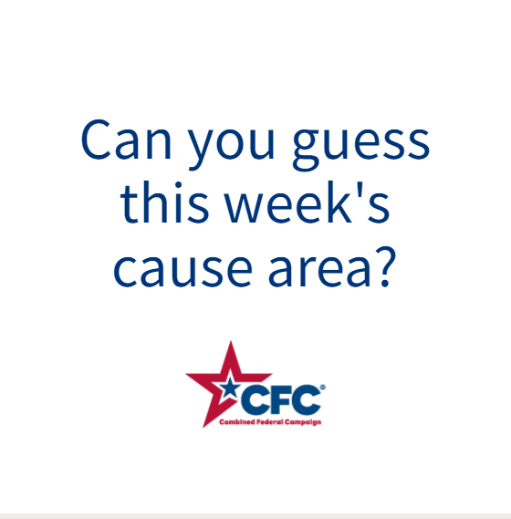 | ALT Text:  Video featuring a photo of a horse being shod, a woman and girl feeding chickens and pigs, a hand holding baby sea turtles, and a girl touching a dog on the nose. It reveals the cause of the week to be Animal Welfare.
Wednesday, Nov 1  Through the @USOPM CFC, you can GIVE HAPPY so animal lovers like Evan can find companionship through rescue. #GiveCFC | Thumbnail image provided for reference. Download the actual graphic/video from the Campaign worker Toolkit before posting.  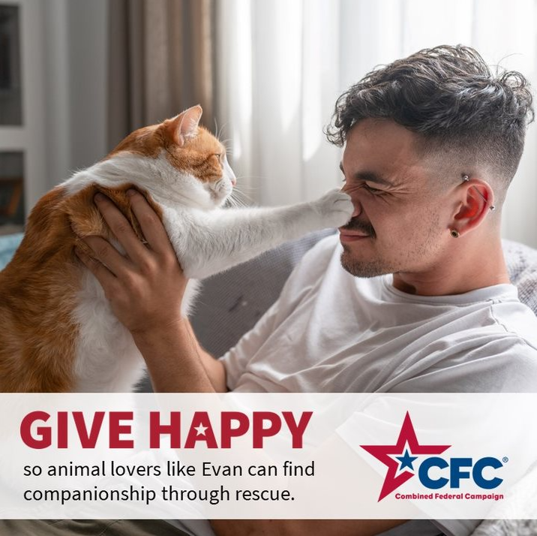 | ALT Text:  Photo of a man holding a ginger and white cat that is batting his nose with its paw: “GIVE HAPPY so animal lovers like Evan can find companionship through rescue.”
Friday, Nov 3  Friday fun: Don’t let the animals down!  This week, we’ve highlighted Animal Welfare as our @USOPM CFC cause of the week. #GiveCFC | Thumbnail image provided for reference. Download the actual graphic/video from the Campaign worker Toolkit before posting.  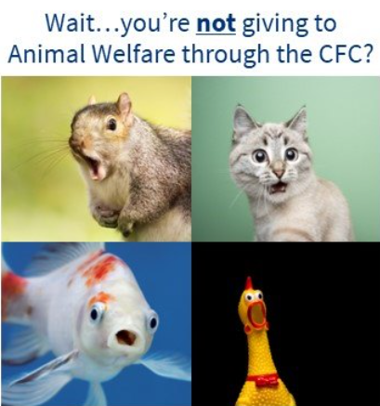 | ALT Text:  Four images of animals with their mouths open: a squirrel, a kitten, a goldfish, and a rubber chicken. Text reads “Wait…you’re not giving to Animal Welfare through the CFC?”

