Social Media Copy – Arts & Humanities Week
Share these posts and accompanying graphics with your agency’s or installation’s social media manager. Be sure to download the graphic or video from the toolkit as a separate file to get the best resolution. Alternatively, you can “share” the posts you want to promote directly from: https://www.facebook.com/CombinedFederalCampaign/
Monday, Oct 23  Can you guess the @USOPM CFC cause of the week?  If you guessed “Arts & Humanities” you are right! Learn more at GiveCFC.org/cause-week. #GiveCFC | Thumbnail image provided for reference. Download the actual graphic/video from the Campaign worker Toolkit before posting.  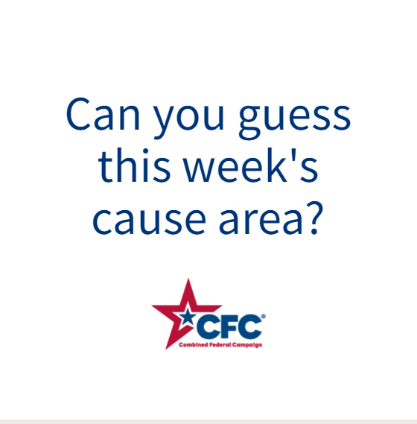 | ALT Text:  Video featuring a photo of a little girl playing messily with paints, a woman taking photos of art in a museum, men recording a video, and a hand removing a book from a library shelf. It reveals the cause of the week to be Arts & Humanities.
Wednesday, Oct 25  Through the @USOPM CFC, you can GIVE HAPPY so creative young artists like Chloe can develop their talents. #GiveCFC | Thumbnail image provided for reference. Download the actual graphic/video from the Campaign worker Toolkit before posting.  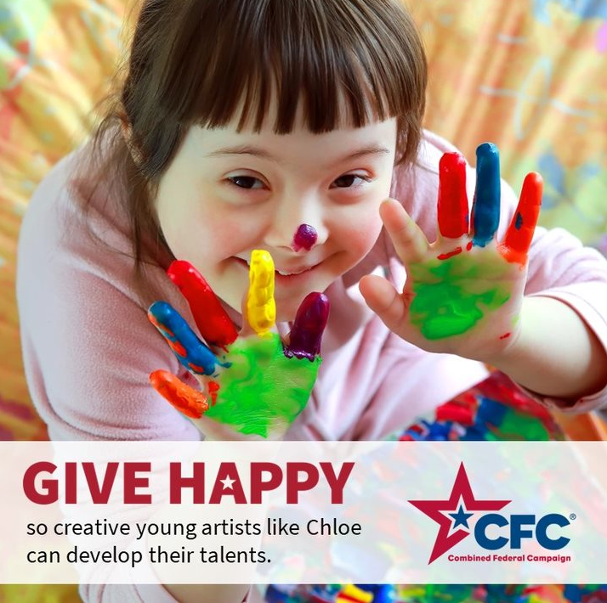 | ALT Text:  Photo of a girl with paint all over her hands and text: “GIVE HAPPY so creative young artists like Chloe can develop their talents.”
Friday, Oct 27  Friday fun: Tell us who you think wore it best in the comments below!  This week, we’ve enjoyed celebrating Arts & Humanities as our @USOPM CFC cause of the week. #GiveCFC | Thumbnail image provided for reference. Download the actual graphic/video from the Campaign worker Toolkit before posting.  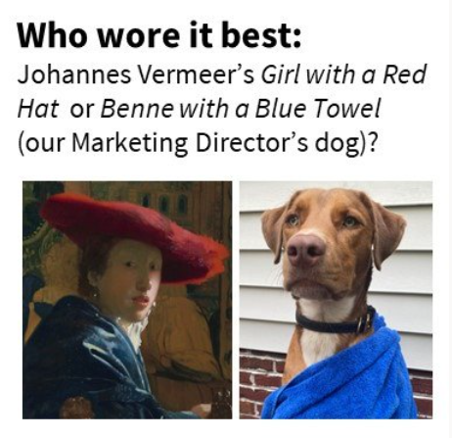 | ALT Text:  Image of a painting of a Dutch woman in a red hat and blue velvet wrap next to a photo of a dog wrapped in a blue towel. Text “Who wore it best? Johannes Vermeer’s Girl with a Red Hat or Benne with a Blue Towel (our Marketing Director’s dog)?

