Social Media Copy – Children & Family Support Week
Share these posts and accompanying graphics with your agency’s or installation’s social media manager. Be sure to download the graphic or video from the toolkit as a separate file to get the best resolution. Alternatively, you can “share” the posts you want to promote directly from: https://www.facebook.com/CombinedFederalCampaign/
Monday, Dec 25  Can you guess the @USOPM CFC cause of the week?  If you guessed “Children & Family Support” you are right! Learn more at GiveCFC.org/cause-week. #GiveCFC | Thumbnail image provided for reference. Download the actual graphic/video from the Campaign worker Toolkit before posting. | ALT Text:  Video featuring a pediatrician high fiving a young patient, a mom hugging her son with an American flag around his shoulders, a dad teaching a child to ride a bike, and boys practicing soccer. It reveals the cause of the week to be Children & Family Support.
Wednesday, Dec 27  Through the @USOPM CFC, you can GIVE HAPPY so families like the Lees can expand their families through adoption. #GiveCFC | Thumbnail image provided for reference. Download the actual graphic/video from the Campaign worker Toolkit before posting. | ALT Text:  Photo of a family sitting together looking at documents in a folder: “GIVE HAPPY so couples like the Lees can expand their families through adoption.”
Friday, Dec 29  Friday fun: You mean to tell me…my CFC donation can help children and families in need?  What a perfect week to highlight Children & Family Support as our @USOPM CFC cause of the week. #GiveCFC | Thumbnail image provided for reference. Download the actual graphic/video from the Campaign worker Toolkit before posting.  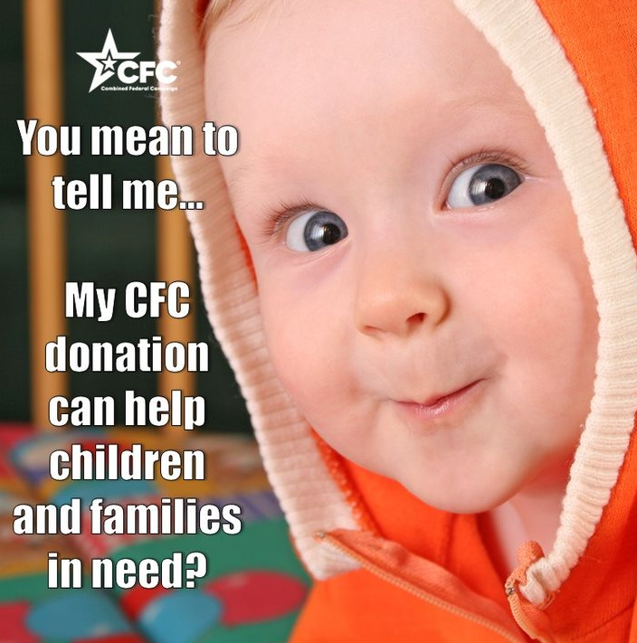 | ALT Text:  Image of a baby looking at the camera with text “You mean to tell me…my CFC donation can help children and families in need?”

