Social Media Copy – Community Improvement Week
Share these posts and accompanying graphics with your agency’s or installation’s social media manager. Be sure to download the graphic or video from the toolkit as a separate file to get the best resolution. Alternatively, you can “share” the posts you want to promote directly from: https://www.facebook.com/CombinedFederalCampaign/
Monday, Nov 13  Can you guess the @USOPM CFC cause of the week?  If you guessed “Community Improvement” you are right! Learn more at GiveCFC.org/cause-week. #GiveCFC | Thumbnail image provided for reference. Download the actual graphic/video from the Campaign worker Toolkit before posting.  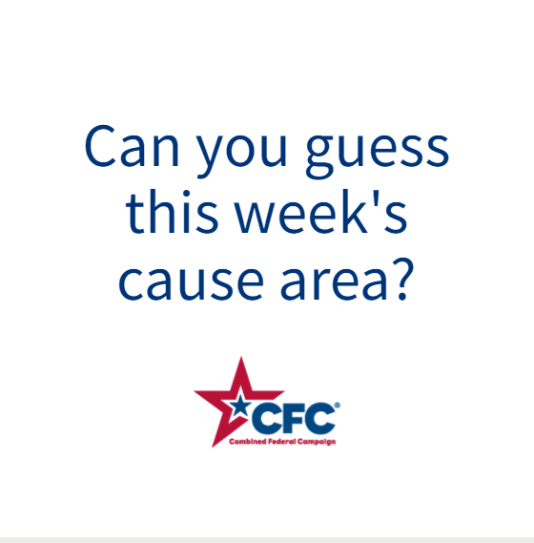 | ALT Text:  Video featuring a photo online group therapy; community members planting a tree; children at computers in a library; and adults playing basketball. It reveals the cause of the week to be Community Improvement.
Wednesday, Nov 15  Through the @USOPM CFC, you can GIVE HAPPY so neighborhoods can plant their own community gardens. #GiveCFC | Thumbnail image provided for reference. Download the actual graphic/video from the Campaign worker Toolkit before posting.  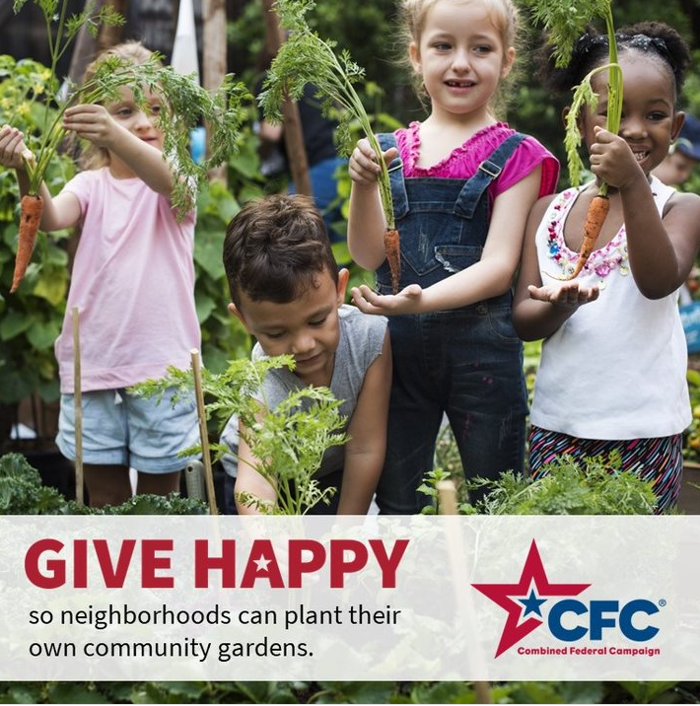 | ALT Text:  Photo of a group of children in a garden: “GIVE HAPPY so neighborhoods can plant their own community gardens.”
Friday, Nov 17  Friday fun: Having a perfect lawn won’t actually improve your community, but giving through the CFC can!  This week, we’ve highlighted Community Improvement as our @USOPM CFC cause of the week. #GiveCFC | Thumbnail image provided for reference. Download the actual graphic/video from the Campaign worker Toolkit before posting.  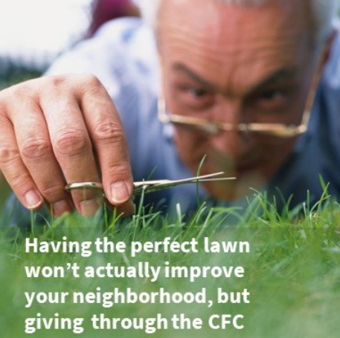 | ALT Text:  Image of a man clipping his grass with nail scissors and text “Having the perfect lawn won’t actually improve your neighborhood, but giving through the CFC can!”

