Social Media Copy – Disaster & Crisis Response Week
Share these posts and accompanying graphics with your agency’s or installation’s social media manager. Be sure to download the graphic or video from the toolkit as a separate file to get the best resolution. Alternatively, you can “share” the posts you want to promote directly from: https://www.facebook.com/CombinedFederalCampaign/
Monday, Oct 9  Can you guess the @USOPM CFC cause of the week?  If you guessed “Disaster & Crisis Response” you are right! Learn more at GiveCFC.org/cause-week. #GiveCFC | Thumbnail image provided for reference. Download the actual graphic/video from the Campaign worker Toolkit before posting.  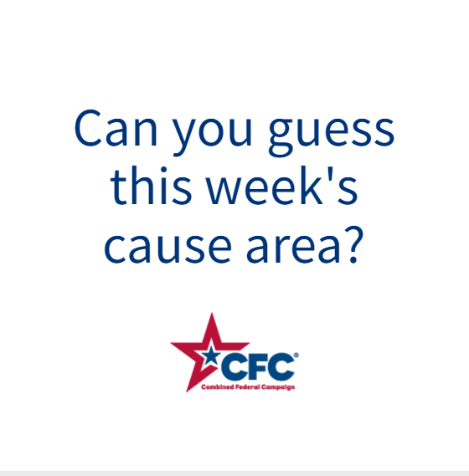 | ALT Text:  Video featuring a photo of a firefighter and little girl holding a teddy bear; women cleaning up in the rubble after a tornado; a man handing another man a box of supplies, a woman in a hard hat holding a clipboard. It reveals the cause of the week to be Disaster & Crisis Response.
Wednesday, Oct 11  Through the @USOPM CFC, you can GIVE HAPPY so first responders like Andre can have the equipment they need to save lives. #GiveCFC | Thumbnail image provided for reference. Download the actual graphic/video from the Campaign worker Toolkit before posting.  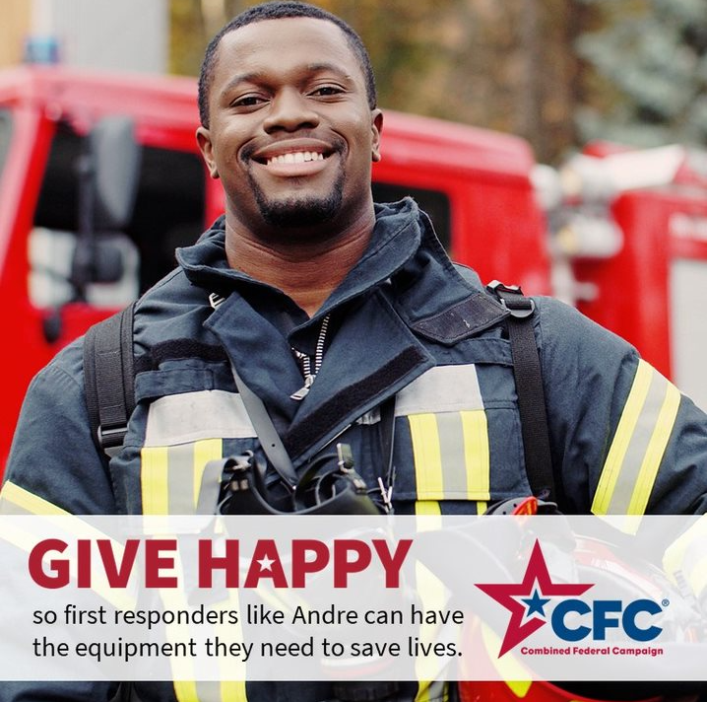 | ALT Text:  Photo of a smiling firefighter in front of a fire truck with the text “GIVE HAPPY so first responders like Andre can have the equipment they need to save lives.”
Friday, Oct 13  Friday fun: Disasters can happen to anyone.  This week we highlighted Disaster & Crisis Response as the @USOPM CFC cause of the week. Your gift through the CFC can ensure that help is there for any disaster, big and small. #GiveCFC | Thumbnail image provided for reference. Download the actual graphic/video from the Campaign worker Toolkit before posting. | ALT Text:  Image of a person with their face hidden by a pile of toilet paper they are holding and text “I like being prepared for emergencies.”

