Social Media Copy – Education Week
Share these posts and accompanying graphics with your agency’s or installation’s social media manager. Be sure to download the graphic or video from the toolkit as a separate file to get the best resolution. Alternatively, you can “share” the posts you want to promote directly from: https://www.facebook.com/CombinedFederalCampaign/
Monday, Oct 2  Can you guess the @USOPM CFC cause of the week?  If you guessed “Education” you are right! Learn more at GiveCFC.org/cause-week. #GiveCFC | Thumbnail image provided for reference. Download the actual graphic/video from the Campaign worker Toolkit before posting.  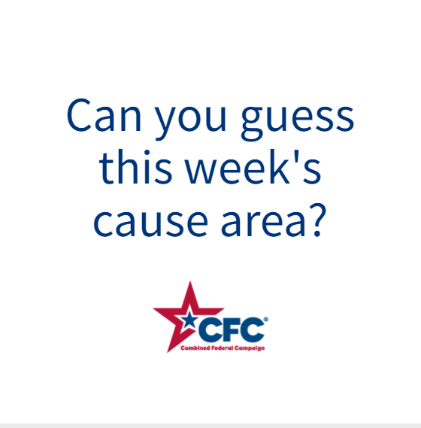 | ALT Text:  Video featuring photos of a woman in a graduation cap and gown; adult students working at a computer in a library; a young woman and child playing with blocks; and a group of children in goggles watching a science experiment. It reveals the cause of the week to be Education.
Wednesday, Oct 4  Through the @USOPM CFC, you can GIVE HAPPY so students like Tanya can earn the degree of their dreams. #GiveCFC | Thumbnail image provided for reference. Download the actual graphic/video from the Campaign worker Toolkit before posting.  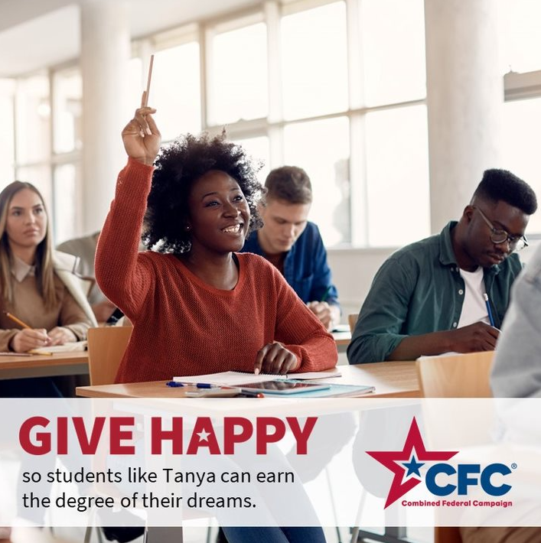 | ALT Text:  Photo of a woman in a classroom with her hand raised and text “GIVE HAPPY so students like Tanya can earn the degree of their dreams.”
Friday, Oct 6  Friday fun: How did your week go?  This week we highlighted Education as the @USOPM CFC cause of the week. Our hearts go out to all the teachers and educators out there. You are heroes! #GiveCFC | Thumbnail image provided for reference. Download the actual graphic/video from the Campaign worker Toolkit before posting. | ALT Text:  Image of a very clean classroom on the left and a messy room covered in paint splatters on the right. Text: “HAPPY Friday! How is your week going? How it started: How its going:”

