Social Media Copy – End Poverty Week
Share these posts and accompanying graphics with your agency’s or installation’s social media manager. Be sure to download the graphic or video from the toolkit as a separate file to get the best resolution. Alternatively, you can “share” the posts you want to promote directly from: https://www.facebook.com/CombinedFederalCampaign/
Monday, Oct 16  Can you guess the @USOPM CFC cause of the week?  If you guessed “End Poverty” you are right! Learn more at GiveCFC.org/cause-week. #GiveCFC | Thumbnail image provided for reference. Download the actual graphic/video from the Campaign worker Toolkit before posting.  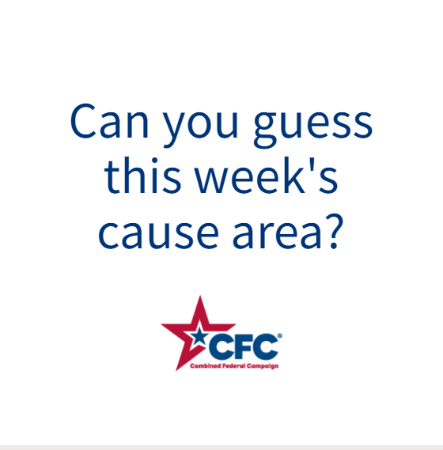 | ALT Text:  Video featuring a photo of a small business owner in a basket shop; a little girl in Africa drinking water from a pipe; hands organizing boxes of canned food: and a farmer packing crates of produce. It reveals the cause of the week to be End Poverty.
Wednesday, Oct 18  Through the @USOPM CFC, you can GIVE HAPPY so entrepreneurs like Mei can open their own small businesses. #GiveCFC | Thumbnail image provided for reference. Download the actual graphic/video from the Campaign worker Toolkit before posting.  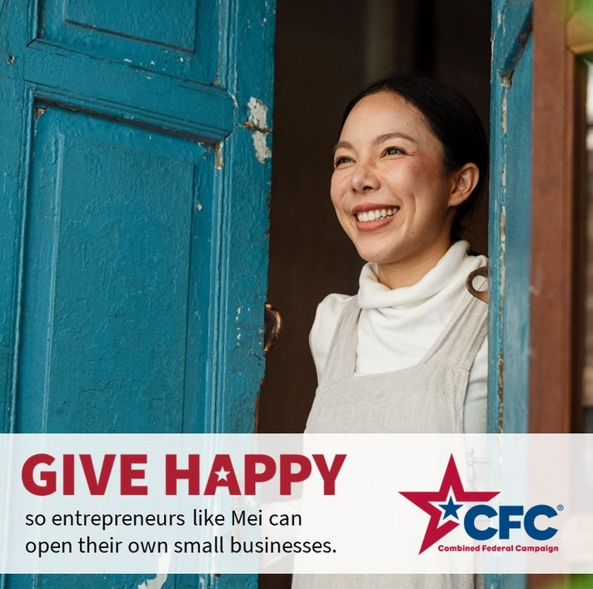 | ALT Text:  Photo of a smiling woman standing in a doorway with the text “GIVE HAPPY so entrepreneurs like Mei can open their own small businesses.”
Friday, Oct 20  Friday fun: We can all do our part in our own way.  This week, the effort to End Poverty was the @USOPM CFC cause of the week. #GiveCFC | Thumbnail image provided for reference. Download the actual graphic/video from the Campaign worker Toolkit before posting.  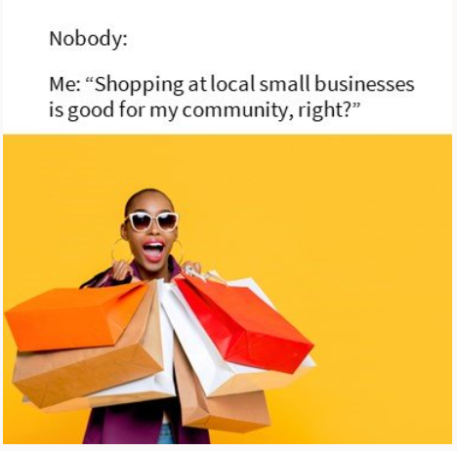 | ALT Text:  Image of a woman holding shopping bags and text “Nobody:” and “Me: Shopping at local small businesses is good for my community, right?”

