Social Media Copy – Environmental Protection Week
Share these posts and accompanying graphics with your agency’s or installation’s social media manager. Be sure to download the graphic or video from the toolkit as a separate file to get the best resolution. Alternatively, you can “share” the posts you want to promote directly from: https://www.facebook.com/CombinedFederalCampaign/
Monday, Dec 11  Can you guess the @USOPM CFC cause of the week?  If you guessed “Environmental Protection” you are right! Learn more at GiveCFC.org/cause-week. #GiveCFC | Thumbnail image provided for reference. Download the actual graphic/video from the Campaign worker Toolkit before posting.  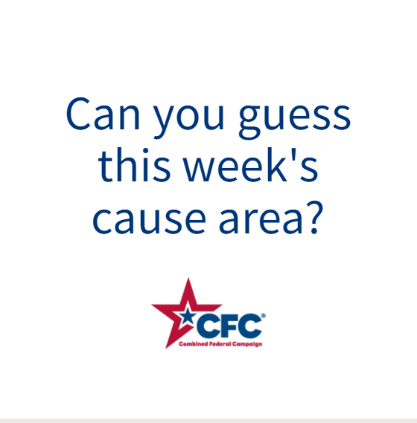 | ALT Text:  Video featuring a photo wind turbans, hands holding baby sea turtles, a woman planting a tree, and a recycling bin. It reveals the cause of the week to be Environmental Protection.
Wednesday, Dec 13  Through the @USOPM CFC, you can GIVE HAPPY so our next generation can enjoy vibrant sea life for years to come. #GiveCFC | Thumbnail image provided for reference. Download the actual graphic/video from the Campaign worker Toolkit before posting.  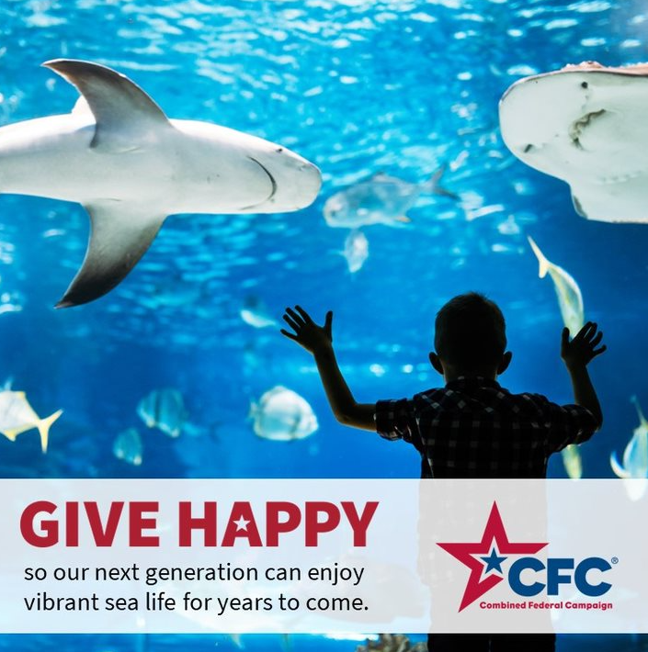 | ALT Text:  Photo of a child standing in front of an aquarium tank with sharks swimming by: “GIVE HAPPY so our next generation can enjoy vibrant sea life for years to come.”
Friday, Dec 15  Friday fun: The old saying is true: “The best time to plant a tree was 20 years ago. The second-best time is today.”  You can help make the world better for future generations through the Environmental Protection @USOPM cause of the week. #GiveCFC | Thumbnail image provided for reference. Download the actual graphic/video from the Campaign worker Toolkit before posting.  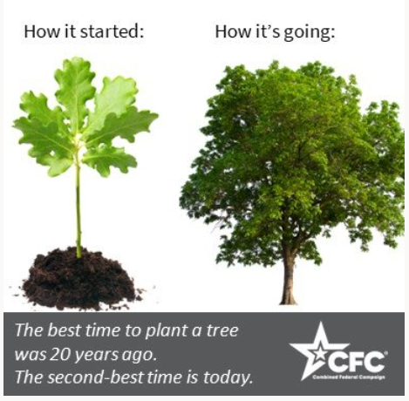 | ALT Text:  Image of an oak sapling and a large oak tree with text above each saying “How it started” and “How it’s going”

