Social Media Copy – Food & Nutrition Week
Share these posts and accompanying graphics with your agency’s or installation’s social media manager. Be sure to download the graphic or video from the toolkit as a separate file to get the best resolution. Alternatively, you can “share” the posts you want to promote directly from: https://www.facebook.com/CombinedFederalCampaign/
Monday, Sept 25  Can you guess the @USOPM CFC cause of the week?  If you guessed “Food & Nutrition” you are right! Learn more at GiveCFC.org/cause-week. #GiveCFC | Thumbnail image provided for reference. Download the actual graphic/video from the Campaign worker Toolkit before posting.  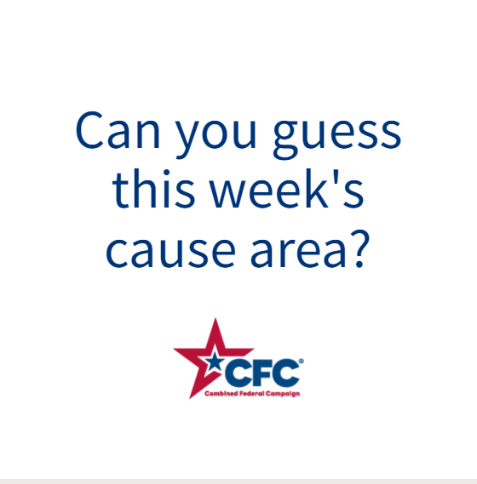 | ALT Text:  Video featuring photos of people handing out cans of food, a nutritionist’s meal plan, a couple cooking together, and a little girl feeding a chicken. It reveals the cause of the week to be Food & Nutrition.
Wednesday, Sept 27  Through the @USOPM CFC, you can GIVE HAPPY so children like Amelia can start their school day with a full belly. #GiveCFC | Thumbnail image provided for reference. Download the actual graphic/video from the Campaign worker Toolkit before posting.  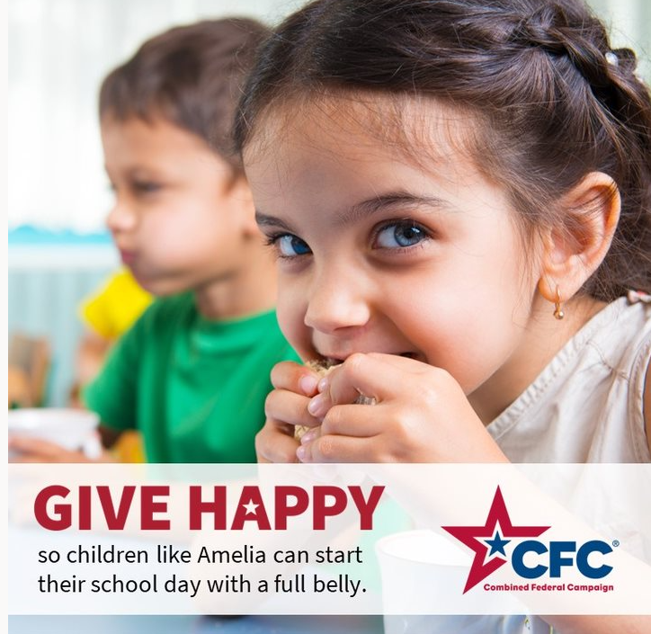 | ALT Text:  Image of a little girl eating a sandwich and text “GIVE HAPPY so children like Amelia can start their school day with a full belly.”
Friday, Sept 29  Friday fun: We ARE partial to potatoes around here.  As we wrap up Food & Nutrition week at the @USOPM CFC, we want to know: what are you looking forward to eating this weekend? #GiveCFC | Thumbnail image provided for reference. Download the actual graphic/video from the Campaign worker Toolkit before posting.  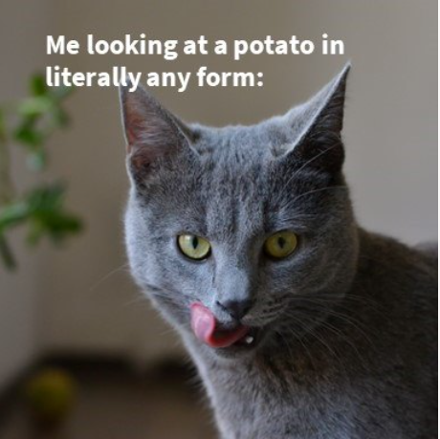 | ALT Text:  Image of a grey cat licking its lips and the text “Me looking at a potato in literally any form:”

