Social Media Copy – Global Health & Research Week
Share these posts and accompanying graphics with your agency’s or installation’s social media manager. Be sure to download the graphic or video from the toolkit as a separate file to get the best resolution. Alternatively, you can “share” the posts you want to promote directly from: https://www.facebook.com/CombinedFederalCampaign/
Monday, Dec 18  Can you guess the @USOPM CFC cause of the week?  If you guessed “Global Health & Research” you are right! Learn more at GiveCFC.org/cause-week. #GiveCFC | Thumbnail image provided for reference. Download the actual graphic/video from the Campaign worker Toolkit before posting.  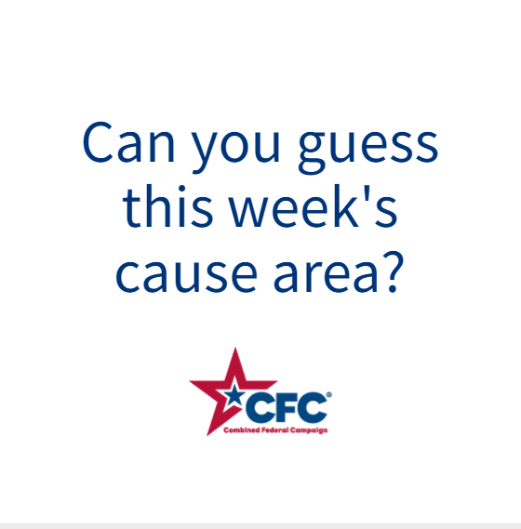 | ALT Text:  Video featuring a photo of a microscope, a doctor listening to a child’s lungs, a premature baby hand holding an adult hand, two people talking in sign language. It reveals the cause of the week to be Global Heath & Research.
Wednesday, Dec 20  Through the @USOPM CFC, you can GIVE HAPPY so patients like John can hear, “You’re in remission!” #GiveCFC | Thumbnail image provided for reference. Download the actual graphic/video from the Campaign worker Toolkit before posting. | ALT Text:  Photo of an elderly patient with his doctor: “GIVE HAPPY so patients like John can hear, “You’re in remission!”
Friday, Dec 22  Friday fun: Anyone else feel seen here?  This week, we’ve highlighted Global Health & Research as our @USOPM CFC cause of the week. #GiveCFC | Thumbnail image provided for reference. Download the actual graphic/video from the Campaign worker Toolkit before posting.  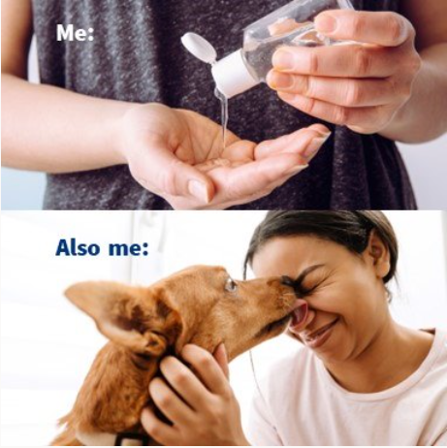 | ALT Text:  Image of a woman applying hand sanitizer and the text “Me:”. Image of a woman being licked in the face by a dog and the text “Also me:”.

