Social Media Copy – Housing & Shelter Week
Share these posts and accompanying graphics with your agency’s or installation’s social media manager. Be sure to download the graphic or video from the toolkit as a separate file to get the best resolution. Alternatively, you can “share” the posts you want to promote directly from: https://www.facebook.com/CombinedFederalCampaign/
Monday, Nov 20  Can you guess the @USOPM CFC cause of the week?  If you guessed “Housing & Shelter” you are right! Learn more at GiveCFC.org/cause-week. #GiveCFC | Thumbnail image provided for reference. Download the actual graphic/video from the Campaign worker Toolkit before posting.  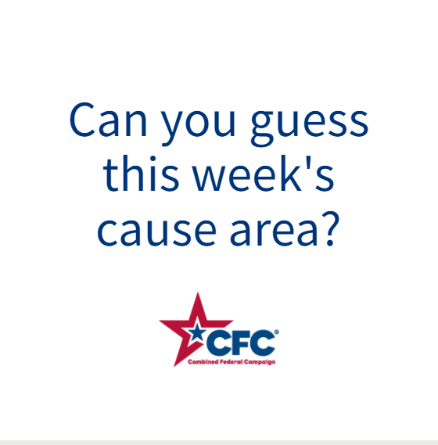 | ALT Text:  Video featuring a photo of a man in a wheelchair on a ramp, a woman’s hands holding a child’s hand holding a wooden house; two men working on a house frame, and a family looking at a house. It reveals the cause of the week to be Housing & Shelter.
Wednesday, Nov 22  Through the @USOPM CFC, you can GIVE HAPPY so wounded warriors like Jennifer can live in accessible homes. #GiveCFC | Thumbnail image provided for reference. Download the actual graphic/video from the Campaign worker Toolkit before posting.  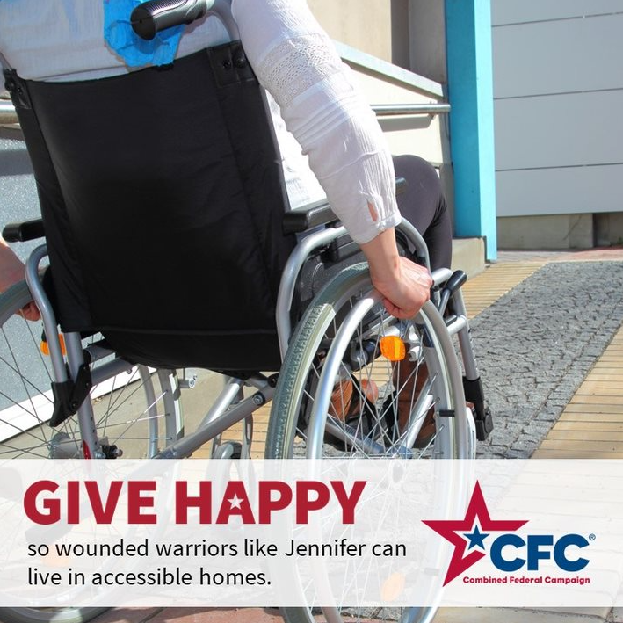 | ALT Text:  Photo of a woman in a wheelchair going up a ramp with the text “GIVE HAPPY so wounded warriors like Jennifer can live in accessible homes.”
Friday, Nov 24  Friday fun: Which house makes you the most HAPPY? Let us know in the comments.  Housing is definitely something to be thankful for. This week, we celebrated Housing & Shelter for the @USOPM CFC cause of the week. #GiveCFC | Thumbnail image provided for reference. Download the actual graphic/video from the Campaign worker Toolkit before posting. | ALT Text:  Images of four houses: A on the beach; B a stone cottage; C modern home and D a lakeside mountain cabin and text “Which house makes you happy?”

