Social Media Copy – Human Rights Week
Share these posts and accompanying graphics with your agency’s or installation’s social media manager. Be sure to download the graphic or video from the toolkit as a separate file to get the best resolution. Alternatively, you can “share” the posts you want to promote directly from: https://www.facebook.com/CombinedFederalCampaign/
Monday, Dec 4  Can you guess the @USOPM CFC cause of the week?  If you guessed “Human Rights” you are right! Learn more at GiveCFC.org/cause-week. #GiveCFC | Thumbnail image provided for reference. Download the actual graphic/video from the Campaign worker Toolkit before posting.  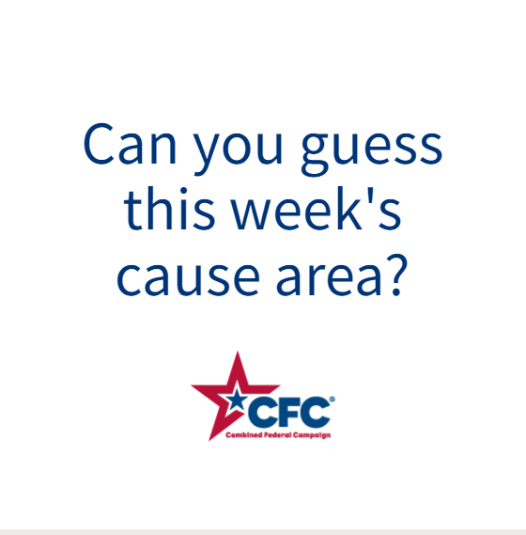 | ALT Text:  Video featuring a photo of many different hands holding in a circle, woman holding her right hand up in a fist, hands signing some documents and person throwing open some curtains. It reveals the cause of the week to be Human Rights.
Wednesday, Dec 6  Through the @USOPM CFC, you can GIVE HAPPY so voices like Cheyenne’s can be heard. #GiveCFC | Thumbnail image provided for reference. Download the actual graphic/video from the Campaign worker Toolkit before posting.  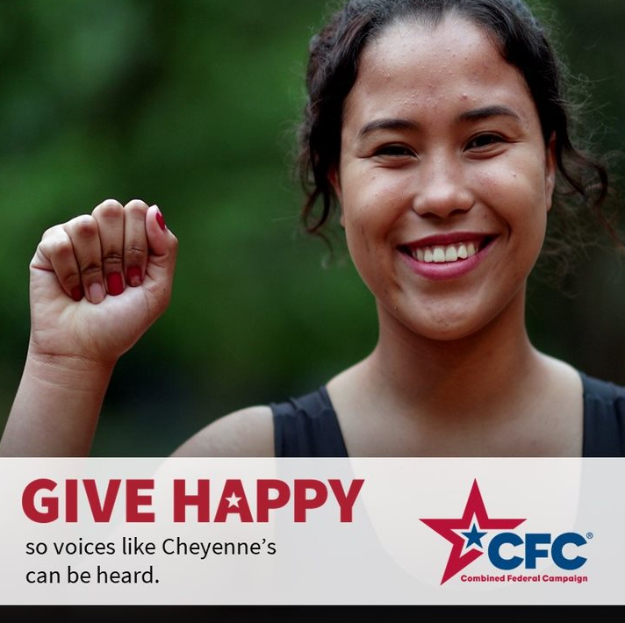 | ALT Text:  Photo of a woman holding up her right fist: “GIVE HAPPY so voices like Cheyenne’s can be heard.”
Friday, Dec 8  This week, we’ve learned more about Human Rights because it was our @USOPM CFC cause of the week. Who’s joining us in supporting this important cause? #GiveCFC | Thumbnail image provided for reference. Download the actual graphic/video from the Campaign worker Toolkit before posting.  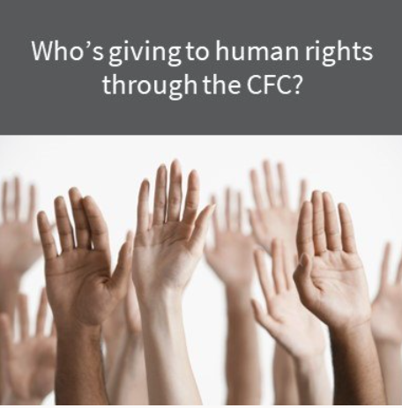 | ALT Text:  Image of multiple hands raised and text “Who’s giving to human rights through the CFC?”

