Social Media Copy – Mental Wellness Week
Share these posts and accompanying graphics with your agency’s or installation’s social media manager. Be sure to download the graphic or video from the toolkit as a separate file to get the best resolution. Alternatively, you can “share” the posts you want to promote directly from: https://www.facebook.com/CombinedFederalCampaign/
Monday, Jan 1  Can you guess the @USOPM CFC cause of the week?  If you guessed “Mental Wellness,” you are right! Learn more at GiveCFC.org/cause-week. #GiveCFC | Thumbnail image provided for reference. Download the actual graphic/video from the Campaign worker Toolkit before posting.  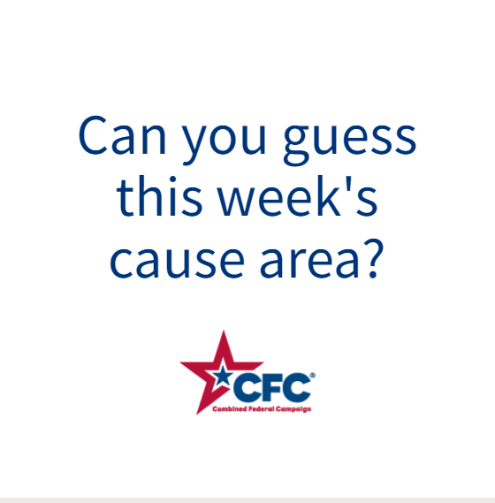 | ALT Text:  Video featuring photos of a hotline operator, a counseling support group, a yoga class, and a man with a dog. It reveals the cause of the week to be Mental Wellness.
Wednesday, Jan 3  Through the @USOPM CFC, you can GIVE HAPPY so kids like Riley can receive the emotional support they need. #GiveCFC | Thumbnail image provided for reference. Download the actual graphic/video from the Campaign worker Toolkit before posting. | ALT Text:  Photo of a boy kissing a dog on the nose: “GIVE HAPPY so kids like Riley can receive the emotional support they need.”
Friday, Jan 5  Friday fun: Keep calm and donate to mental wellness through the CFC.  Actually, the holiday season and start to a new year can be very stressful. You can help by donating to this week’s @USOPM CFC cause of the week: Mental Wellness. #GiveCFC | Thumbnail image provided for reference. Download the actual graphic/video from the Campaign worker Toolkit before posting.  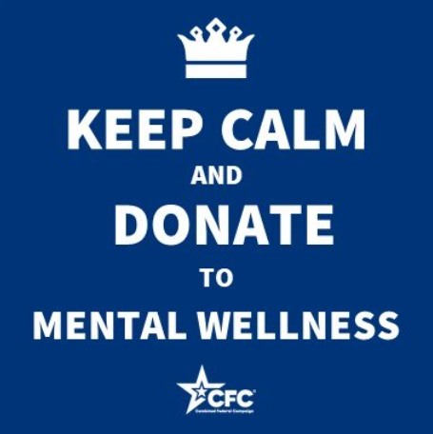 | ALT Text:  Blue background and text “Keep calm and donate to Mental Wellness.”

