Social Media Copy – Military & Veterans Services Week
Share these posts and accompanying graphics with your agency’s or installation’s social media manager. Be sure to download the graphic or video from the toolkit as a separate file to get the best resolution. Alternatively, you can “share” the posts you want to promote directly from: https://www.facebook.com/CombinedFederalCampaign/
Monday, Nov 6  Can you guess the @USOPM CFC cause of the week?  If you guessed “Military & Veterans Services” you are right! Learn more at GiveCFC.org/cause-week. #GiveCFC | Thumbnail image provided for reference. Download the actual graphic/video from the Campaign worker Toolkit before posting.  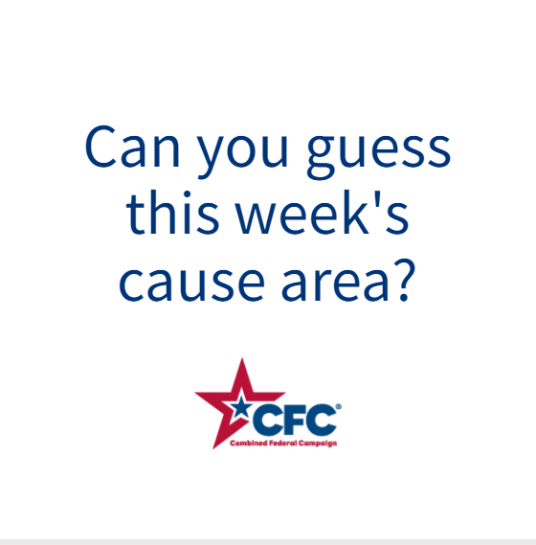 | ALT Text:  Video featuring a photo of a little girl in flight suit holding the hands of her Air Force parents, wounded warriors participating in a wheelchair race, crowds welcoming returning veterans; and a man meeting with a counselor. It reveals the cause of the week to be Military & Veterans Services.
Wednesday, Nov 8  Through the @USOPM CFC, you can GIVE HAPPY so military families like the Reeds can stay connected during deployments. #GiveCFC | Thumbnail image provided for reference. Download the actual graphic/video from the Campaign worker Toolkit before posting.  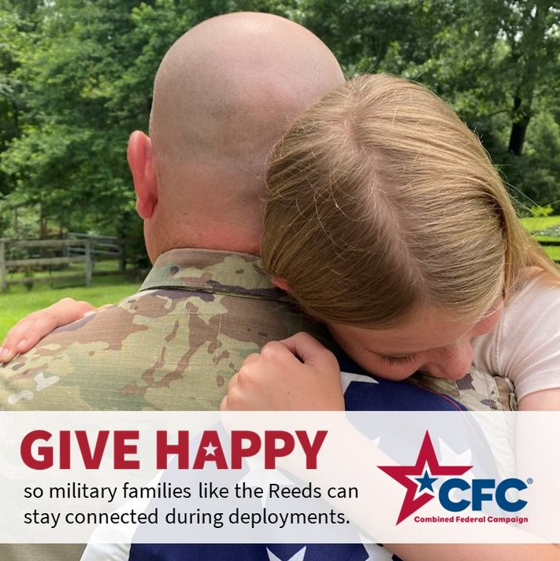 | ALT Text:  Photo of a man in uniform hugging a little girl holding a flag: “GIVE HAPPY so military families like the Reeds can stay connected during deployments.”
Friday, Nov 10  Friday fun: In honor of Veteran’s Day, let us know your favorite branch of service in the comments.  This week, we’ve been honored to celebrate Military & Veterans Services as our @USOPM CFC cause of the week. We thank you all for your service! #GiveCFC | Thumbnail image provided for reference. Download the actual graphic/video from the Campaign worker Toolkit before posting. | ALT Text:  Video features a rotating photo of a member from each branch of the armed services.

