Social Media Copy – Finish Strong Week
Share these posts and accompanying graphics with your agency’s or installation’s social media manager. Be sure to download the graphic or video from the toolkit as a separate file to get the best resolution. Alternatively, you can “share” the posts you want to promote directly from: https://www.facebook.com/CombinedFederalCampaign/
Monday, Jan 8  5 days left in the @USOPM CFC! This week we are spelling the word H-A-P-P-Y.  Today, “H” stands for “Hours”: Federal employees can also pledge volunteer hours through the CFC. Pledge 5 volunteer hours to the charity of your choice today! #GiveCFC | Thumbnail image provided for reference. Download the actual graphic/video from the Campaign worker Toolkit before posting.  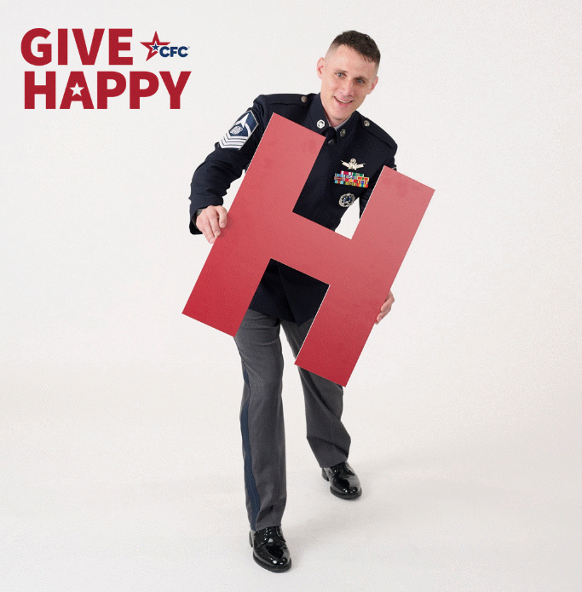 | ALT Text:  Image of a Guardian from the U.S. Space Force employee holding a red letter “H”.
Tuesday, Jan 9  4 days left in the @USOPM CFC! This week we are spelling the word H-A-P-P-Y!  Today, “A” stands for “Advocate”. Spread the word: here are 4 great reasons to give through the CFC: (1) give through payroll deduction; (2) give to multiple vetted charities at once; (3) give together for greater impact; (4) GIVE HAPPY. #GiveCFC | Thumbnail image provided for reference. Download the actual graphic/video from the Campaign worker Toolkit before posting.  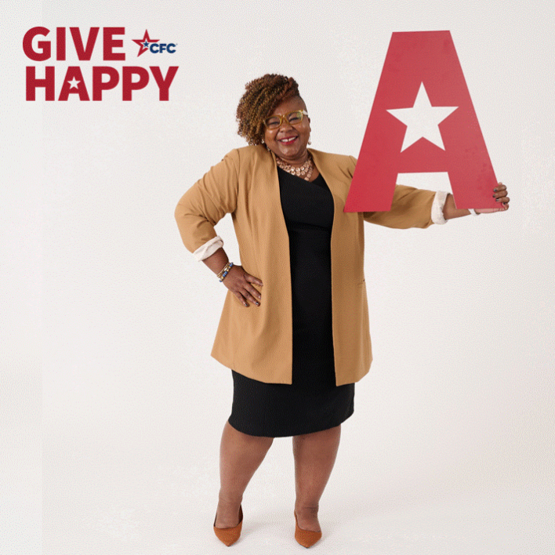 | ALT Text:  Image of a Federal employee holding a red letter “A”.
Wednesday, Jan 10  3 days left in the @USOPM CFC! This week we are spelling the word H-A-P-P-Y.  Today, “P” stands for “Peer-to-Peer”. The CFC is a peer-to-peer campaign. Here are 3 ways to show the CFC is important to you: (1) Ask a co-worker which cause of the week was their favorite. (2) Like, comment, or share a CFC social media post. (3) Submit your Give Happy goes global photo. #GiveCFC | Thumbnail image provided for reference. Download the actual graphic/video from the Campaign worker Toolkit before posting.  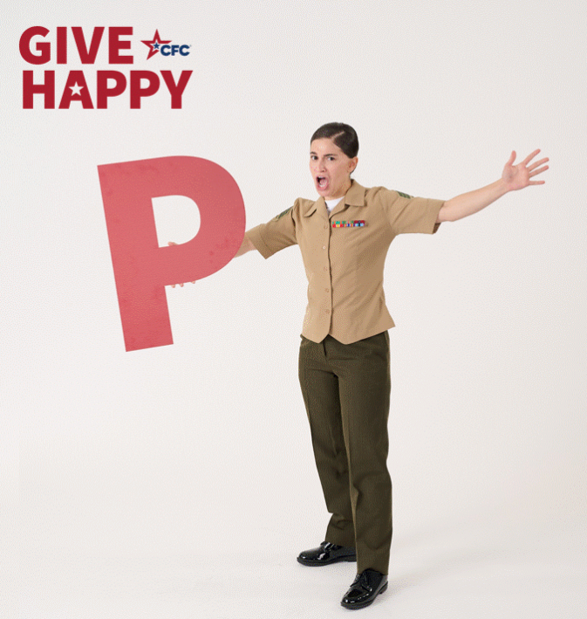 | ALT Text:  GIF with various images of a U.S. Marine holding a red letter “P.”
Thursday, Jan 11  2 days left in the @USOPM CFC! This week we are spelling the word H-A-P-P-Y.  Today, the second “P” in H-A-P-P-Y, stands for “Peruse”. Visit the Virtual Charity Fair and choose 2 charities to learn more about. Watching their videos will only take 2 minutes of your time. GiveCFC.org #GiveCFC | Thumbnail image provided for reference. Download the actual graphic/video from the Campaign worker Toolkit before posting.  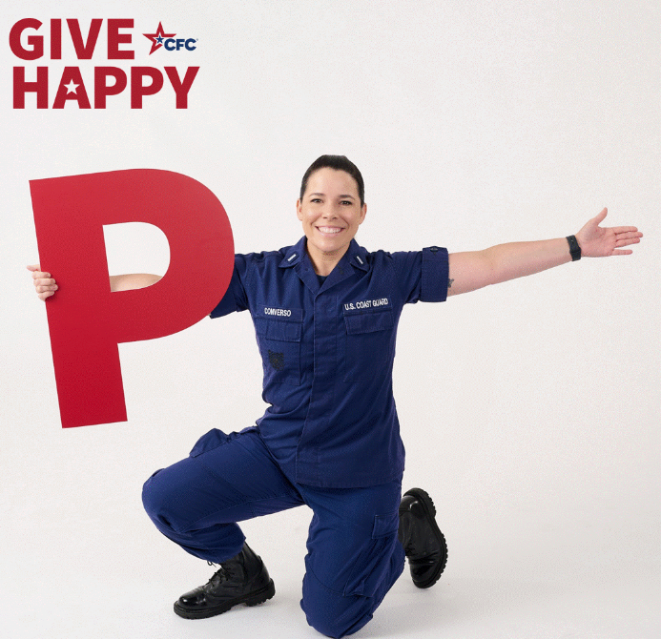 | ALT Text:  Image of a member of the U.S. Coast Guard holding a red letter “P.”
Friday, Jan 12  1 day left in the @USOPM CFC! This week we are spelling out the word H-A-P-P-Y.  Today, “Y” stands for “You.” There’s only 1 you. Join us! Just $5 per paycheck (or even a one-time gift of $5 can make a big difference. The online pledge system is open through Monday, Jan 15 for you to complete your pledge. #GiveCFC | Thumbnail image provided for reference. Download the actual graphic/video from the Campaign worker Toolkit before posting.  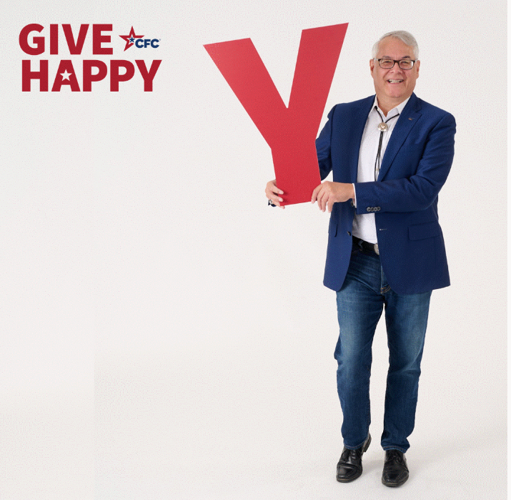 | ALT Text:  Image of a Federal employee holding a red letter “Y.”

