Social Media Copy – Giving Tuesday Week
Share these posts and accompanying graphics with your agency’s or installation’s social media manager. Be sure to download the graphic or video from the toolkit as a separate file to get the best resolution. Alternatively, you can “share” the posts you want to promote directly from: https://www.facebook.com/CombinedFederalCampaign/
Monday, Nov 27  Something important happens tomorrow! You’ve heard about Black Friday and Cyber Monday... get ready to join us for Giving Tuesday. Help make this the biggest pledge day through the @USOPM Combined Federal Campaign. #GiveCFC | Thumbnail image provided for reference. Download the actual graphic/video from the Campaign worker Toolkit before posting.  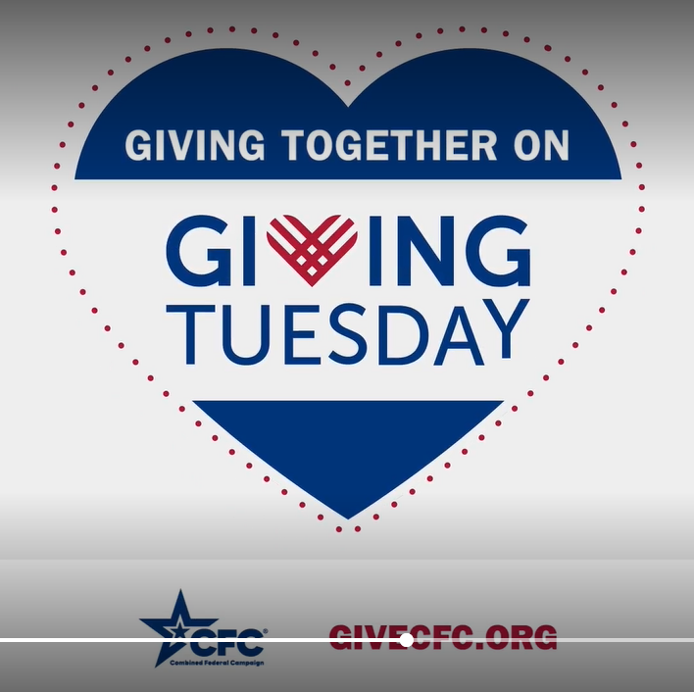 | ALT Text:  Video draws a red heart graphic, which fades into a larger blue heart with red dots around it. Text in the heart reads: Giving together on Giving Tuesday. GiveCFC.org”
Tuesday, Nov 28  Today’s the day! Join us and GIVE HAPPY on Giving Tuesday through the @USOPM CFC. #GiveCFC | Thumbnail image provided for reference. Download the actual graphic/video from the Campaign worker Toolkit before posting.  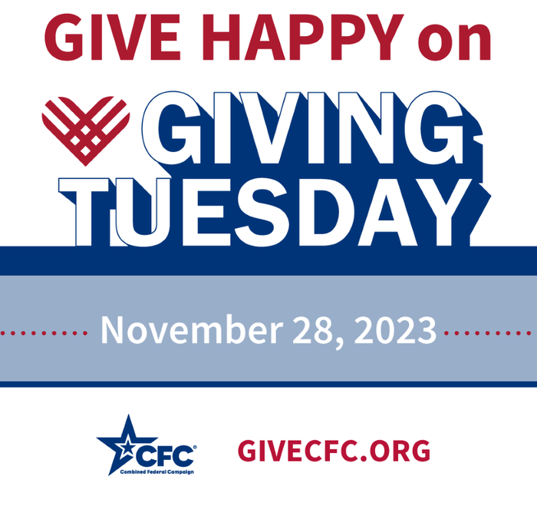 | ALT Text:  Blue and red graphic with text “GIVE HAPPY on Giving Tuesday. November 28, 2023 GiveCFC.org”
Wednesday, Nov 29  THANK YOU! Your generosity made Giving Tuesday the biggest online pledge day of the @USOPM CFC. #GiveCFC | Thumbnail image provided for reference. Download the actual graphic/video from the Campaign worker Toolkit before posting.  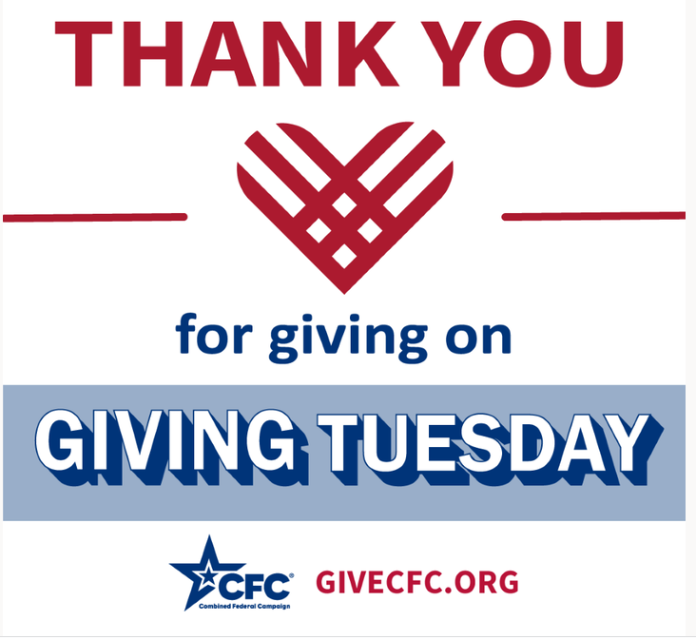 | ALT Text:  Red heart surrounded by the text “Thank you for giving on Giving Tuesday” GiveCFC.org
Friday, Dec 1  Friday fun: Ready? Set. Go! The Holiday Giving Season starts now.  A gift through the @USOPM CFC to your favorite charitable cause will keep making a difference throughout the year. #GiveCFC | Thumbnail image provided for reference. Download the actual graphic/video from the Campaign worker Toolkit before posting. | ALT Text:  Photo of a man holding a bunch of gold and red wrapped packages with bows. Text reads: “POV; You are giving to charitable causes this holiday season!”

