Social Media Copy – Start Strong Week
Share these posts and accompanying graphics with your agency’s or installation’s social media manager. Be sure to download the graphic or video from the toolkit as a separate file to get the best resolution. Alternatively, you can “share” the posts you want to promote directly from: https://www.facebook.com/CombinedFederalCampaign/
Monday, Sept 18  The @USOPM Combined Federal Campaign is off to a great start. Learn more about the campaign by visiting GiveCFC.org. #GiveHappy | Thumbnail image provided for reference. Download the actual graphic/video from the Campaign worker Toolkit before posting. | ALT Text:  Video featuring various Federal employees holding the letter G-I-V-E H-A-P-P-Y at the CFC photo shoot.
Wednesday, Sept 20  There are many fundraising efforts out there, so why give through the @USOPM CFC?  Four great reasons are that you can (1) give through payroll deduction; (2) give to multiple, vetted charities with one pledge, (3) give together with your coworkers to make an even greater impact, and (4) GIVE HAPPY to people and communities in need. Learn even more reasons at GiveCFC.org. #GiveCFC | Thumbnail image provided for reference. Download the actual graphic/video from the Campaign worker Toolkit before posting.  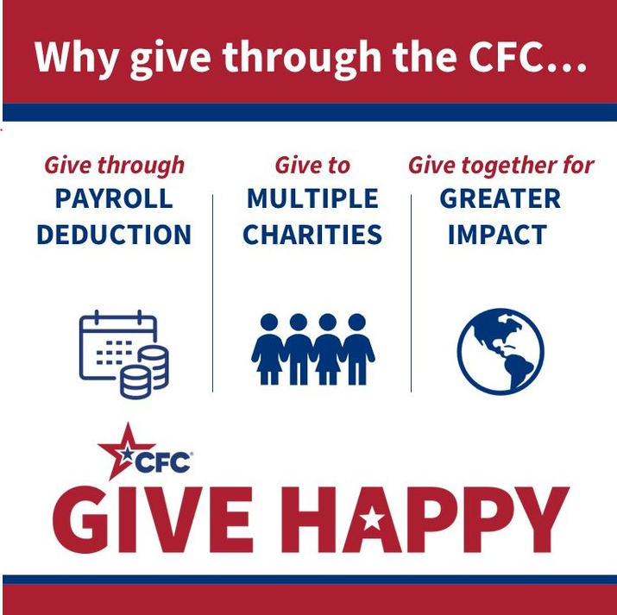 | ALT Text:  Red a blue graphic with the text: Why give through the CFC? Give through payroll deduction, give to multiple charities, give together for greater impact, and GIVE HAPPY.
Friday, Sept 22  Friday fun: be like this chicken and give to help those in need through the @USOPM CFC today! | Thumbnail image provided for reference. Download the actual graphic/video from the Campaign worker Toolkit before posting.  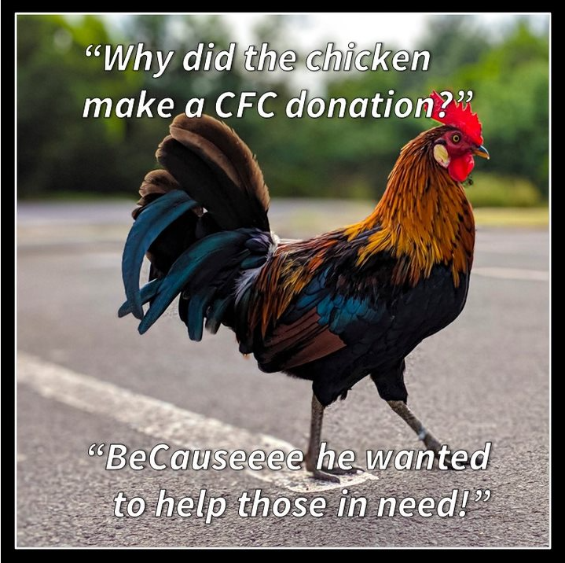 | ALT Text:  Image of a colorful rooster and the text “Why did the chicken make a CFC donation? BeCauseee he wanted to help those in need!”

