Social Media Copy – Thank You Week
Share these posts and accompanying graphics with your agency’s or installation’s social media manager. Be sure to download the graphic or video from the toolkit as a separate file to get the best resolution. Alternatively, you can “share” the posts you want to promote directly from: https://www.facebook.com/CombinedFederalCampaign/
Monday, Jan 15  Today is the last day to pledge through the @USOPM CFC using the online giving system. Just look at all the happiness your gift can bring to people and communities in need. GiveCFC.org #GiveHappy | Thumbnail image provided for reference. Download the actual graphic/video from the Campaign worker Toolkit before posting.  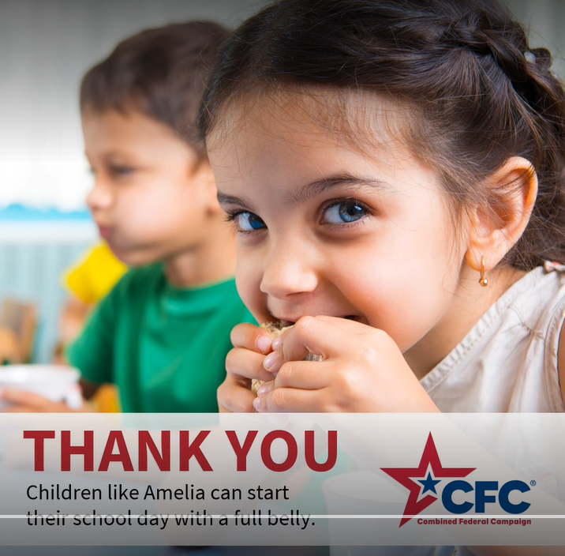 | ALT Text:  Video featuring THANK YOU and images from the various cause of the weeks.
Wednesday, Jan 17  Thank you for your generous support of the 2023 @USOPM CFC! #GiveCFC | Thumbnail image provided for reference. Download the actual graphic/video from the Campaign worker Toolkit before posting.  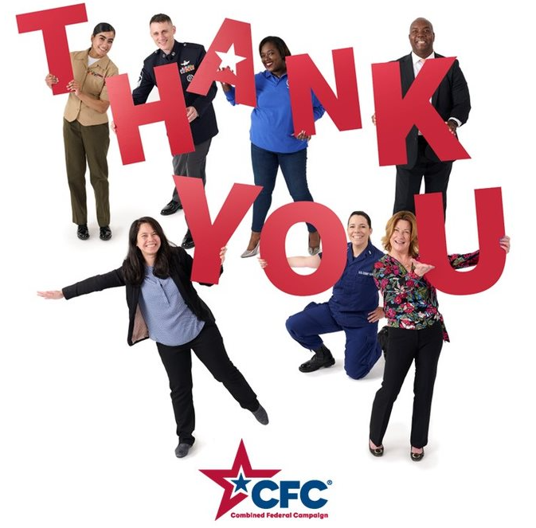 | ALT Text:  Photo shows Federal employees holding the letter T-H-A-N-K Y-O-U.
Friday, Jan 19  Friday fun: What you do when you have the most generous coworkers, and you exceed your CFC goal.  THANK YOU, Federal community! #GiveCFC | Thumbnail image provided for reference. Download the actual graphic/video from the Campaign worker Toolkit before posting.  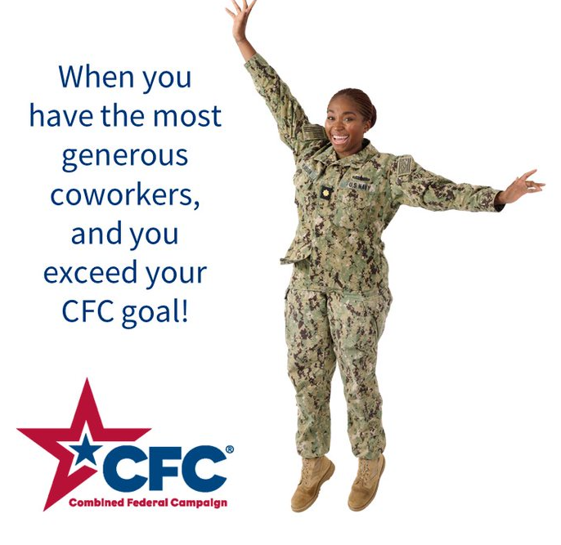 | ALT Text:  Image of a Navy officer jumping into the air and text “POV: when you have the most generous coworkers, and you exceed your CFC goal.”

