Social Media Copy – Welcome Weeks
Share these posts and accompanying graphics with your agency’s or installation’s social media manager. Be sure to download the graphic or video from the toolkit as a separate file to get the best resolution. Alternatively, you can “share” the posts you want to promote directly from: https://www.facebook.com/CombinedFederalCampaign/
Friday, Sept 1  Who’s excited? The @USOPM Combined Federal Campaign Online Giving System officially opens for pledges today! #GiveCFC | Thumbnail image provided for reference. Download the actual graphic/video from the Campaign worker Toolkit before posting. | ALT Text:  Video featuring various Federal employees looking happy and the text “GIVE HAPPY CFC”
Monday, Sept 4  The new theme of the @USOPM CFC is “GIVE HAPPY.” When you give through the CFC, you make the world a happier place. And, studies show that when you GIVE HAPPY, you get happy too! #GiveCFC | Thumbnail image provided for reference. Download the actual graphic/video from the Campaign worker Toolkit before posting. | ALT Text:  Video featuring various Federal employees from the CFC photo shoot holding the letters G-I-V-E H-A-P-P-Y.
Wednesday, Sept 6  What does fall mean to you?  Every fall, Federal employees and retirees have the opportunity to give to causes they care about through the @USOPM Combined Federal Campaign – one of the most successful workplace giving campaigns in the world. #GiveCFC | Thumbnail image provided for reference. Download the actual graphic/video from the Campaign worker Toolkit before posting.  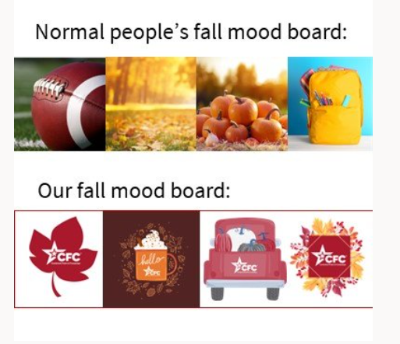 | ALT Text:  Image showing a picture of a football, fall leaves, pile of pumpkins and a backpack with the text “Normal people’s fall mood board” and then a picture of the CFC logo in a red leaf graphic, in an orange coffee mug graphic, on the back of a red truck filled with pumpkins graphic, and on pile of leaves graphic with text “Our fall mood board.”
Friday, Sept 8  Brace yourselves for some Friday fun. Pumpkin season is here and so is the @USOPM CFC! Get ready to see and hear a lot about both this fall. #GiveCFC | Thumbnail image provided for reference. Download the actual graphic/video from the Campaign worker Toolkit before posting. | ALT Text:  Man’s arm holding a pumpkin and the text “Brace yourself pumpkin season is here.”
Tuesday, Sept 12  Join these Federal employees and get happy about the new “GIVE HAPPY” theme this year’s @USOPM CFC. #GiveCFC | Thumbnail image provided for reference. Download the actual graphic/video from the Campaign worker Toolkit before posting. | ALT Text:  Video featuring various Federal employees from the CFC photo shoot holding the letters G-I-V-E H-A-P-P-Y.
Wednesday, Sept 13  Federal employees and retirees make up a very generous community. Your giving spirit has made the @USOPM Combined Federal Campaign so successful – with nearly $8.7 billion pledged since 1961. #GiveCFC | Thumbnail image provided for reference. Download the actual graphic/video from the Campaign worker Toolkit before posting.  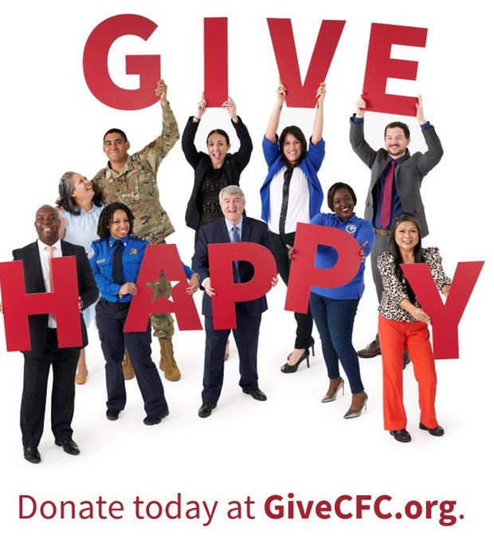 | ALT Text:  Federal employees from various agencies standing together holding the letters G-I-V-E H-A-P-P-Y and text: “Donate today at GiveCFC.org”
Friday, Sept 15  Here is a little Friday fun for our @USOPM CFC Campaign Managers.  You aren’t being lazy, or sending too many emails, or collecting wads of cash, but you are enabling your colleagues to GIVE HAPPY to charitable causes that mean the most to them. Thank you for your service! #GiveCFC | Thumbnail image provided for reference. Download the actual graphic/video from the Campaign worker Toolkit before posting.  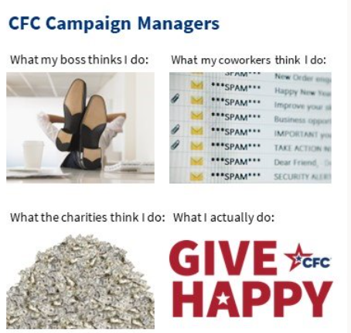 | ALT Text:  Meme entitled “CFC Campaign Managers” and text “What my boss thinks I do” over a photo of feet up on a desk – “What my coworkers think I do” with a photo of an email inbox filled with spam – “What the charities think I do” over a photo of a pile of cash – “What I actually do” over the GIVE HAPPY CFC logo.

