United States Office of Personnel Management

CFC (Combined Federal Campaign) Login.gov Account Guide
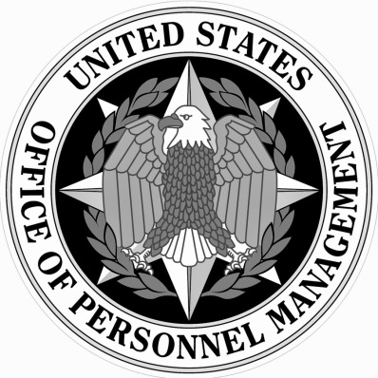
OPM.GOV/CFC
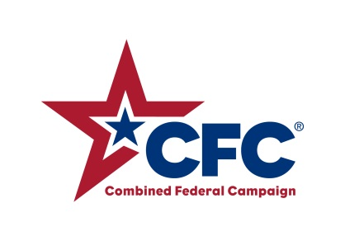
This document will walk through steps to login and setup your CFC Online Giving System pledge account using the new multi-factor authentication system through Login.gov.

Access the Giving System
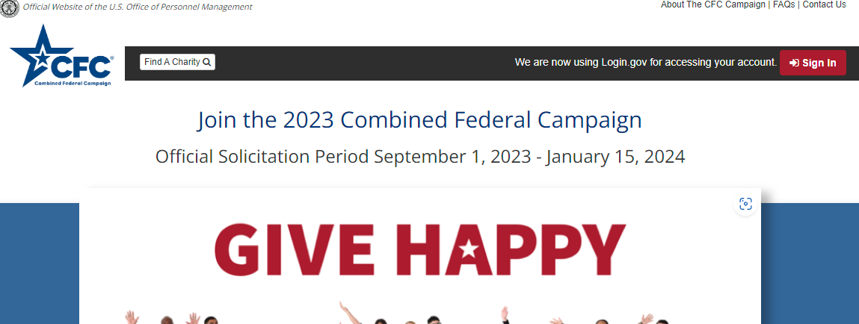
- Navigate to the CFC’s Online Giving System at https://cfcgiving.opm.gov/welcome.
- Click the red “Sign In” button.
Note: If you already have an existing Donor account in the System you should continue to Sign In or Create an Account using the same email address. By doing so the system will automatically link your Login.gov Account to your existing Donor Account.
TIP: If you are accessing the system through your mobile device, it may help to hold the device horizontally.

Sign In
(You already have a Login.gov account and a CFC Donor account under the same email address.)
- Please sign in with your Login.gov Account that matches the email address of your existing Donor account (if one already exists).
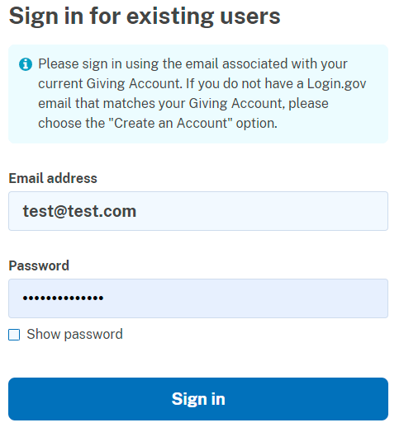
- Alternatively, you can use the “Sign in with your government employee ID” link below the Sign In button. (Note: this will log you in with the primary email associated with your employee ID, if that email is different than your existing donor account it will not automatically provide access to your previous account information, and you will need to contact the Help Center (800-797-0098) to have them link your historical pledge information.)
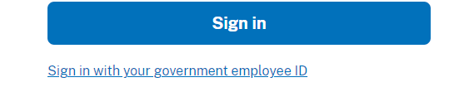
- Once you have entered your Sign In information, the system will prompt Multifactor Authentication. Please enter the authentication method setup for the associated Login.gov Account.

Add an email address to an existing Login.gov Account
(You have a Login.gov account, but it uses a different email address than your CFC Online Giving System donor account.)
      - If you already have a Login.gov account, but it uses a different email address than the one you used to create your CFC Online Giving System donor account, you can log in to your Login.gov account and add an additional email address to your existing account.
      - From the home screen in Login.gov, you can click the “Add a new email address” button.
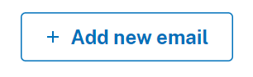
- Type in the email address you use to access your CFC Online Giving System donor account.
- Return to the CFC's Online Giving System (https://cfcgiving.opm.gov/welcome) and try logging in as usual.

Create a Login.gov Account
(You do not have a Login.gov account.)
- If you do not have a Login.gov account or your existing Login.gov account is under a different email than your Donor Account, please Choose Create new account.
- Enter the Email Address associated with your existing Donor Account to ensure your previous donor information can be accessed.
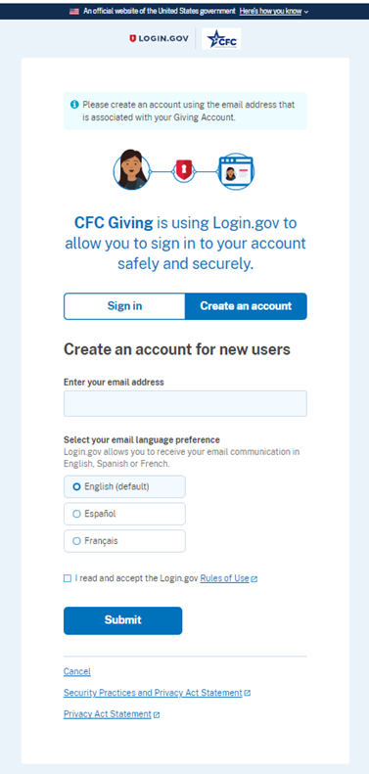
- An email will be sent to confirm the supplied email address. Please follow the link to finish account setup.
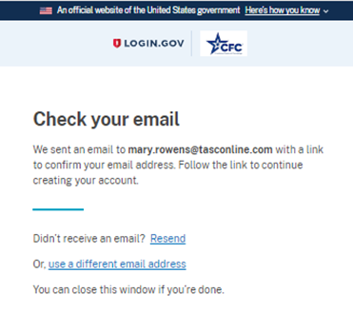
- Confirm your email.
- Setup a New Password Following the on-screen requirements.
- Select the authentication method for MFA (Multi Factor Authentication).
  - Note: Federal Employees should choose either Authentication Application, Security Key or Government ID
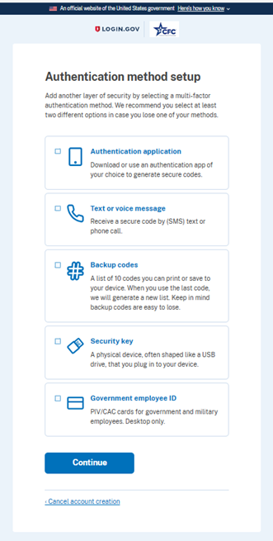
- Based on the method selected, finish the remaining onscreen prompts to complete setup of your MFA method.
- After you have completed setting up your account, you can return to the site and follow the Sign In prompts above.

Frequently Asked Questions
Q: When using Login.gov to access the system will I still have access to my existing Donor Account?
A: Yes. To automatically link your Login.gov account to your existing Donor Account you must sign into Login.gov using the email address associated with your existing donor account.
Q: What should I do if I am having trouble adding an email address to my Login.gov account?
A: Contact the CFC’s Online Giving System Help Center at (800-797-0098) and they can assist with linking your two accounts together.
Q: How do I log out of the system?
A: With the Login.gov integration there are now two sign-outs. When you sign-out of the Giving System, you will be logged into the system, however, your sign in to Login.gov may still be active depending on your account settings. If you want to completely sign out of both systems, please navigate to Login.gov and choose to sign out.

