Social Media – Lemon Face Challenge

Date & Suggested Post | Suggested Graphic | ALT Text
Tuesday, September 10  We are excited to announce this year’s campaign engagement activity: When life gives lemons, GIVE HAPPY!  We encourage you to take part in this year’s challenge to see how we can sweeten life for all through collective impact. Send us YOUR Lemon Face at: CFCMST@givecfc.org and challenge others to take part in the fun and pledge today! 🍋😄 | Thumbnail image provided for reference. Download the actual graphic/video from the Campaign worker Toolkit before posting.  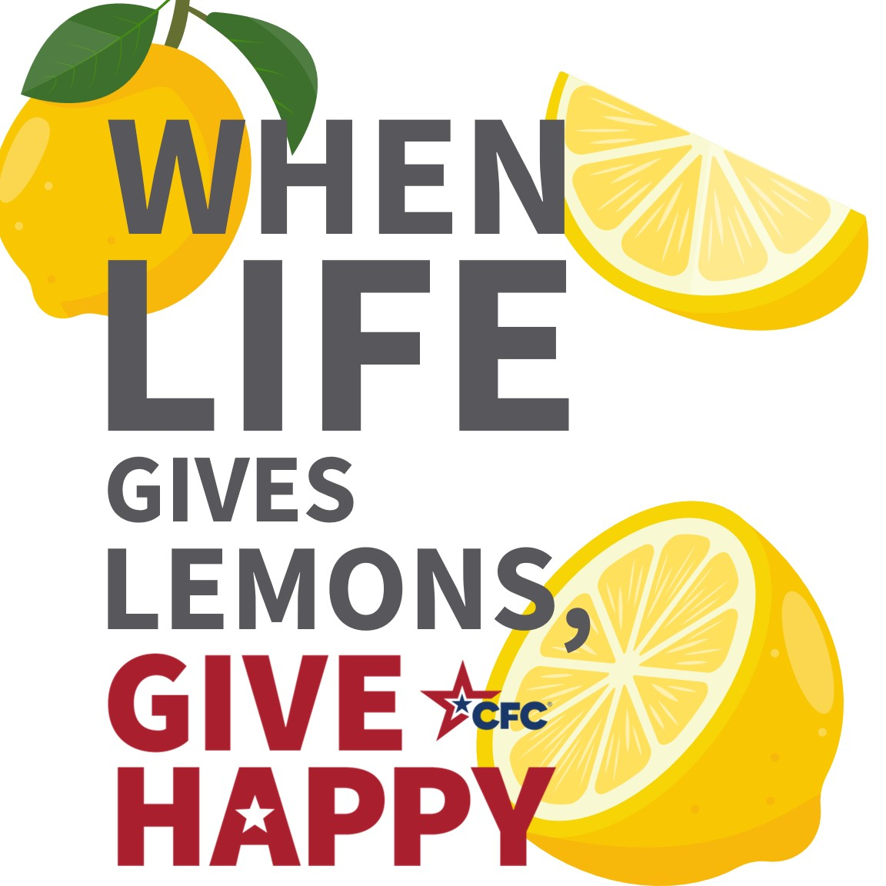 | ALT Text:  When Life Gives You Lemons, GIVE HAPPY with lemon icons.
Tuesday, September 24  It’s time to pucker up and take a bite out of the Lemon Face Challenge!  It’s easy to participate! Do it as a solo challenge, invite your friends or family to take part together, or with colleagues in an all-staff meeting or at a CFC event. Grab a lemon (lemon juice works too!), cut a slice (pour a cup), and take a bite (or a sip) – if you pucker up, then it’s time to GIVE HAPPY! #LemonFaceChallengeCFC 🍋😄 | Thumbnail image provided for reference. Download the actual graphic/video from the Campaign worker Toolkit before posting.  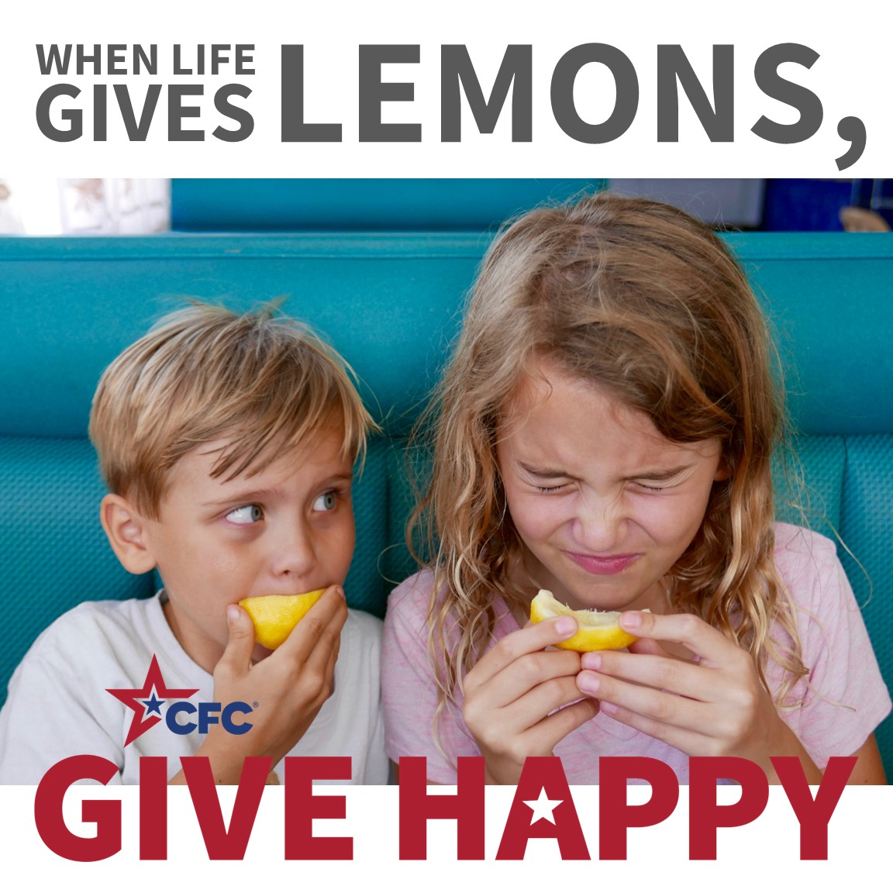 | ALT Text:  When Life Gives You Lemons, GIVE HAPPY with image of young kids biting into a lemon.
Tuesday, October 1  The #LemonFaceChallengeCFC is making a huge Impact! 🍋😄 Check out the Combined Federal Campaign of the XXX participating in the movement to pucker up and GIVE HAPPY! Remember: when life gives you lemons, give happy! Now, send us YOUR Lemon Face at CFCMST@givecfc.org and challenge your friends to join in on the fun! | Thumbnail image provided for reference. Download the actual graphic/video from the Campaign worker Toolkit before posting. 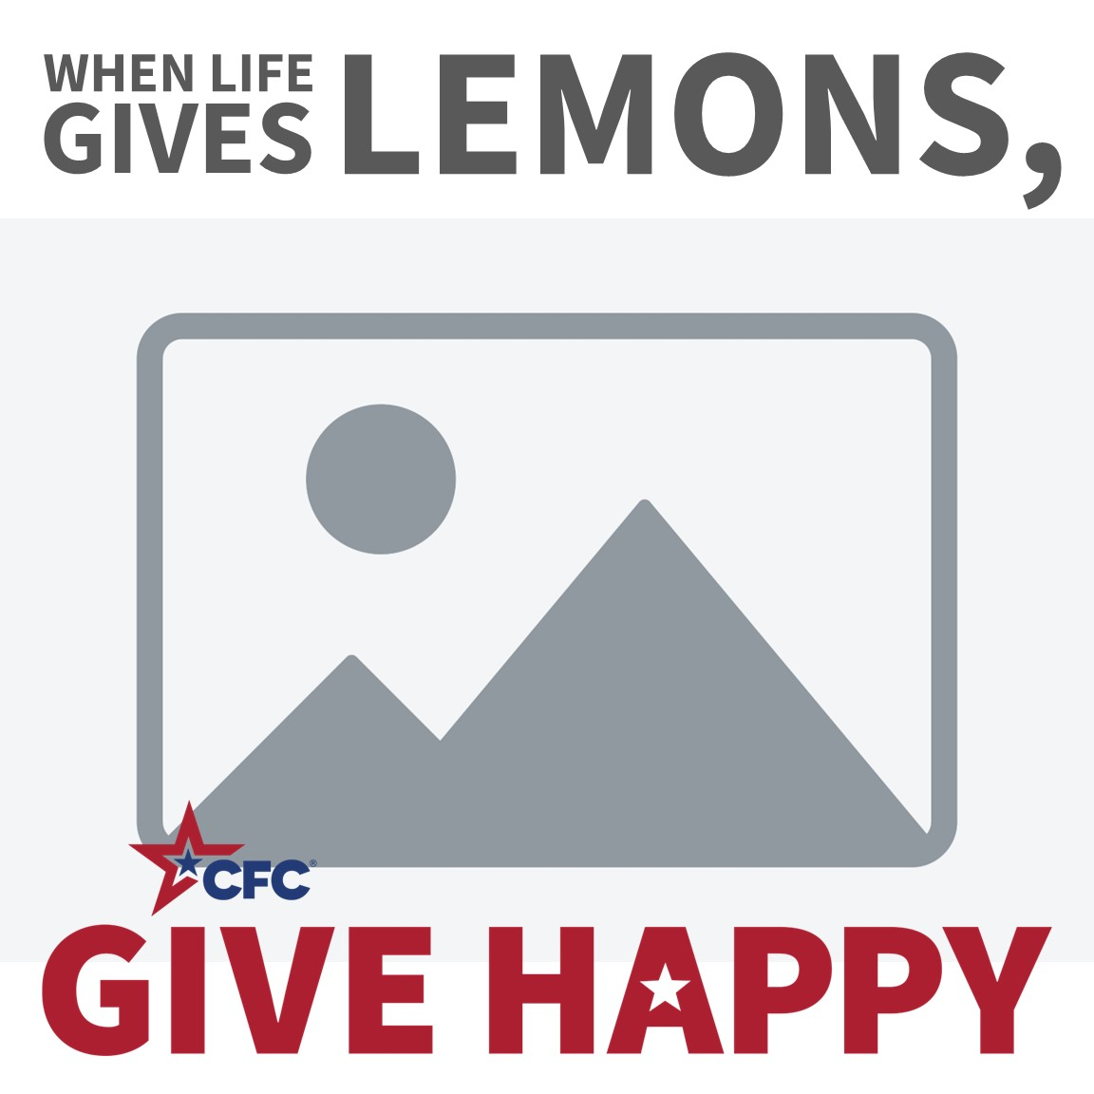 | ALT Text:  TBD
Tuesday, October 8  It is time to take a bite out of the Lemon Face Challenge? It’s as easy as 1-2-3! 🍋😄  - Grab a lemon (or that bottle of lemon juice in the back of your fridge)  - Cut yourself a slice or pour yourself a small amount.  - Take a bite – or a sip – if you pucker up, then it’s time to GIVE HAPPY!  Now, send us YOUR Lemon Face at CFCMST@givecfc.org and challenge your friends to join in on the fun! 🍋😄 #LemonFaceChallengeCFC | Thumbnail image provided for reference. Download the actual graphic/video from the Campaign worker Toolkit before posting.  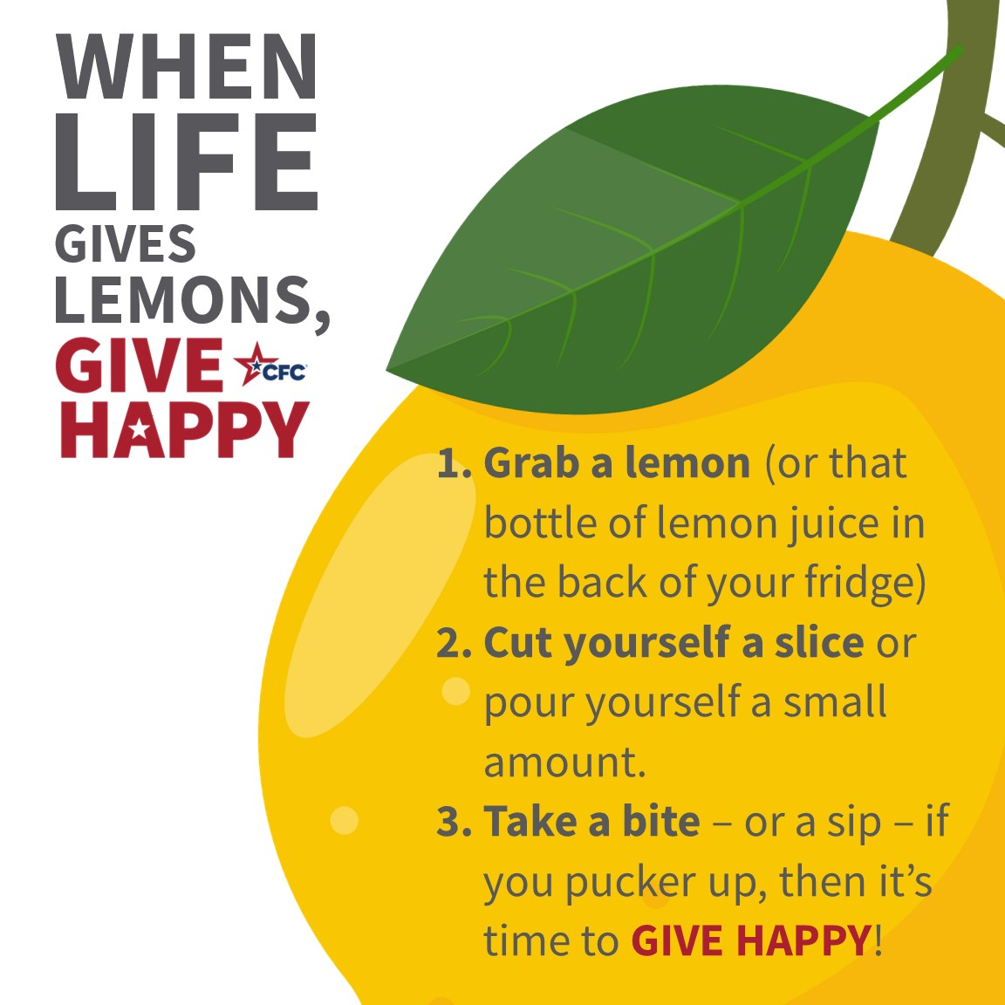 | ALT Text:  When Life Gives You Lemons, GIVE HAPPY with lemon icons.
Tuesday, October 15  It’s time to pucker up and take a bite out of the Lemon Face Challenge! It’s easy to participate: Grab a lemon (lemon juice works too!), cut a slice, take a bite (or a sip) – if you pucker up, then it’s time to GIVE HAPPY!  Send us YOUR Lemon Face at: CFCMST@givecfc.org and challenge others to take part in the fun and pledge today! 🍋😄 | Thumbnail image provided for reference. Download the actual graphic/video from the Campaign worker Toolkit before posting.  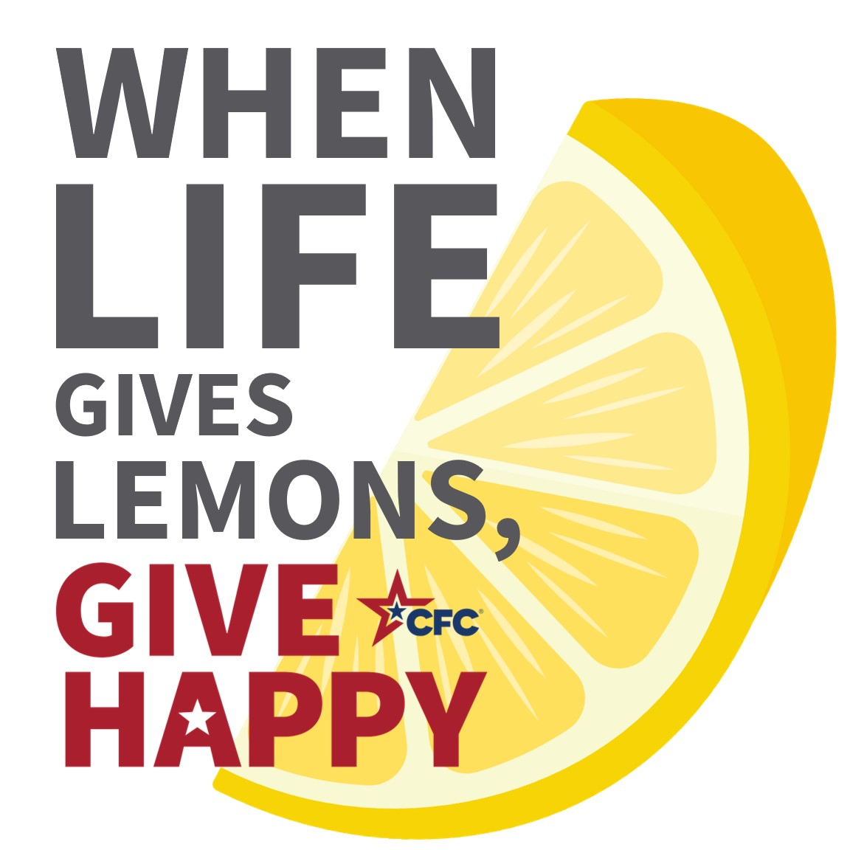 | ALT Text:  When Life Gives You Lemons, GIVE HAPPY with lemon icons.
Tuesday, October 22  We want to see YOUR Lemon Faces! Send us your photos or videos at: CFCMST@givecfc.org and challenge others to take part in the fun and pledge today! 🍋😄  Remember: when life gives you lemons, give happy! | Thumbnail image provided for reference. Download the actual graphic/video from the Campaign worker Toolkit before posting.  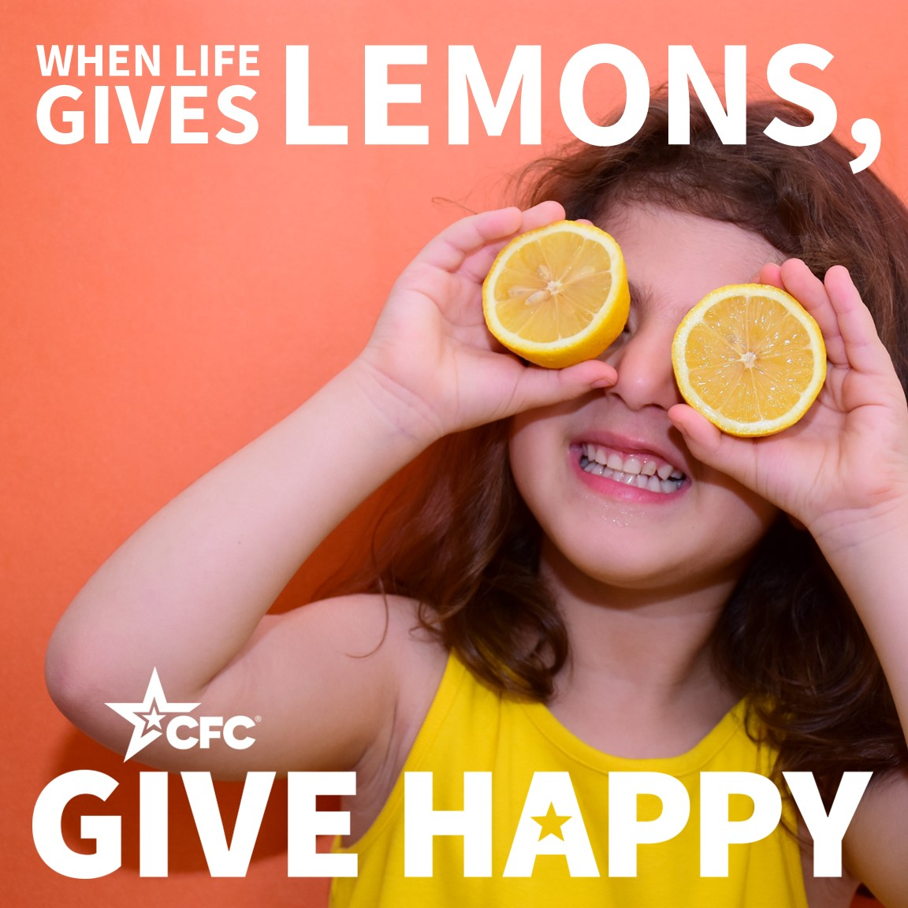 | ALT Text:  When Life Gives You Lemons, GIVE HAPPY with image of young kid biting into a lemon.
Tuesday, October 29  Get ready to make a difference and show off your sour side! It’s as easy as 1-2-3: Grab a lemon (lemon juice works too!), cut a slice (pour a cup), and take a bite (or a sip) – if you pucker up, then it’s time to GIVE HAPPY! We want YOU to join the excitement and send us your Lemon Face at CFCMST@givecfc.org! Challenge your colleagues to take part and pledge today! Remember: when life gives you lemons, give happy! Let’s turn those sour moments into sweet smiles together! #LemonFaceChallengeCFC 🍋😄 | Thumbnail image provided for reference. Download the actual graphic/video from the Campaign worker Toolkit before posting. | ALT Text:  When Life Gives You Lemons, GIVE HAPPY with lemon icons.
Tuesday, November 5  The #LemonFaceChallengeCFC is making a huge Impact! 🍋😄 Check out the Combined Federal Campaign of the XXX participating in the movement to pucker up and GIVE HAPPY!  Remember: when life gives you lemons, give happy! Now, send us YOUR Lemon Face at CFCMST@givecfc.org and challenge your friends to join in on the fun! | Thumbnail image provided for reference. Download the actual graphic/video from the Campaign worker Toolkit before posting. | ALT Text:  TBD
Tuesday, November 12  Let’s turn those frowns upside down and squeeze every drop of joy from this challenge! It’s as easy as 1-2-3: Grab a lemon (lemon juice works too!), cut a slice (pour a cup), and take a bite (or a sip). If you pucker up, then it’s time to GIVE HAPPY! If you powered through and didn’t make a face, congratulations, you’re a superhero! Why not be a hero to a CFC charity and pledge to celebrate? #LemonFaceChallengeCFC 🍋😄 | Thumbnail image provided for reference. Download the actual graphic/video from the Campaign worker Toolkit before posting. | ALT Text:  When Life Gives You Lemons, GIVE HAPPY with lemon icons.
Tuesday, November 19  The #LemonFaceChallengeCFC is making a huge Impact! 🍋😄 Check out the Combined Federal Campaign of the XXX participating in the movement to pucker up and GIVE HAPPY! Remember: when life gives you lemons, give happy! Now, send us YOUR Lemon Face at CFCMST@givecfc.org and challenge your friends to join in on the fun! | Thumbnail image provided for reference. Download the actual graphic/video from the Campaign worker Toolkit before posting. | ALT Text:  TBD
Tuesday, November 26  This Giving Tuesday, we challenge you to do something unusual: bite into a lemon. That’s right! Because when life gives lemons, GIVE HAPPY! Here at the CFC, we know a little something about turning sour situations into something sweet: with a pledge. Now, send us YOUR Lemon Face at CFCMST@givecfc.org and challenge your friends to join in on the fun! #LemonFaceChallengeCFC 🍋😄 | Thumbnail image provided for reference. Download the actual graphic/video from the Campaign worker Toolkit before posting. | ALT Text:  When Life Gives You Lemons, GIVE HAPPY with lemon icons.
Tuesday, December 3  Today is GIVING TUESDAY, and we want to turn those frowns upside down. Because when life gives lemons, GIVE HAPPY!  Now, send us YOUR Lemon Face at CFCMST@givecfc.org and challenge your friends to join in on the fun! #LemonFaceChallengeCFC 🍋😄 | Thumbnail image provided for reference. Download the actual graphic/video from the Campaign worker Toolkit before posting.  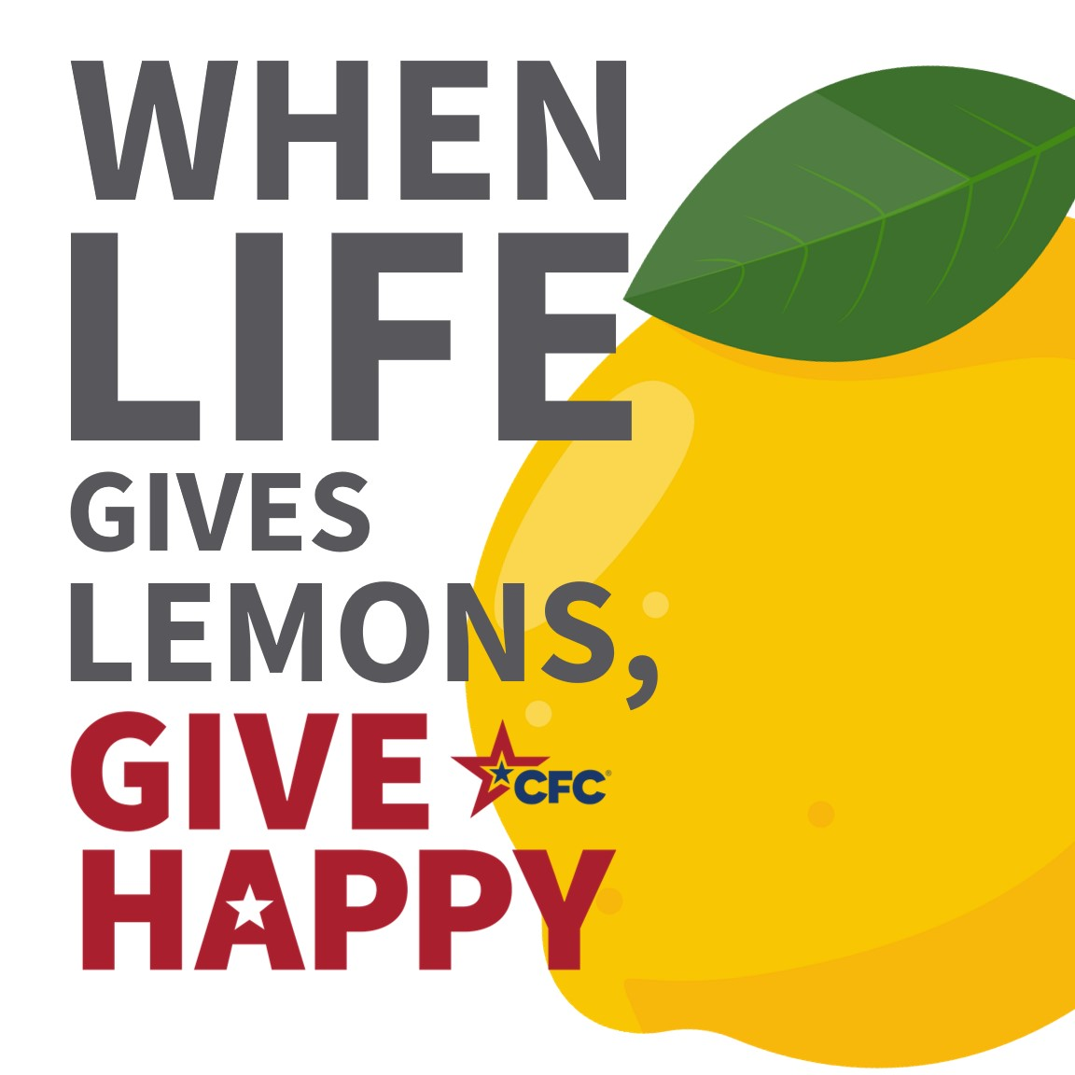 | ALT Text:  When Life Gives You Lemons, GIVE HAPPY with lemon icons.
Tuesday, December 10  The #LemonFaceChallengeCFC is making a huge Impact! 🍋😄 Check out the Combined Federal Campaign of the XXX participating in the movement to pucker up and GIVE HAPPY! Remember: when life gives you lemons, give happy! Now, send us YOUR Lemon Face at CFCMST@givecfc.org and challenge your friends to join in on the fun! | Thumbnail image provided for reference. Download the actual graphic/video from the Campaign worker Toolkit before posting. | ALT Text:  TBD
Tuesday, December 17  Have you joined us in the Lemon Face Challenge yet? If you pucker up, then it’s time to GIVE HAPPY! If you powered through and didn’t make a face, congratulations, you’re a superhero! Why not be a hero to a CFC charity and pledge to celebrate? Send us your Lemon Face at CFCMST@givecfc.org. #LemonFaceChallengeCFC 🍋😄 | Thumbnail image provided for reference. Download the actual graphic/video from the Campaign worker Toolkit before posting. | ALT Text:  When Life Gives You Lemons, GIVE HAPPY with lemon icons.
Tuesday, December 24  The #LemonFaceChallengeCFC is making a huge Impact! 🍋😄 Check out the Combined Federal Campaign of the XXX participating in the movement to pucker up and GIVE HAPPY! Remember: when life gives you lemons, give happy! Now, send us YOUR Lemon Face at CFCMST@givecfc.org and challenge your friends to join in on the fun! | Thumbnail image provided for reference. Download the actual graphic/video from the Campaign worker Toolkit before posting. | ALT Text:  TBD
Tuesday, December 31  Check out the Combined Federal Campaign of the XXX participating in the movement to pucker up and GIVE HAPPY! Remember: when life gives you lemons, give happy! Now, send us YOUR Lemon Face at CFCMST@givecfc.org and challenge your friends to join in on the fun! | Thumbnail image provided for reference. Download the actual graphic/video from the Campaign worker Toolkit before posting. | ALT Text:  TBD
Tuesday, January 7  The Combined Federal Campaign thanks you for taking part in this year’s campaign. When life gives lemons, GIVE HAPPY. That’s what you did. Whether you took part in the Lemon Challenge, joined us for an event, volunteered, or cheered on your colleagues, you had an impact. And collectively, we changed the lives of so many. Don’t forget to send us YOUR Lemon Face at CFCMST@givecfc.org. #LemonFaceChallengeCFC 🍋😄 | Thumbnail image provided for reference. Download the actual graphic/video from the Campaign worker Toolkit before posting. | ALT Text:  When Life Gives You Lemons, GIVE HAPPY with lemon icons.

