**TUESDAY, JULY 23**

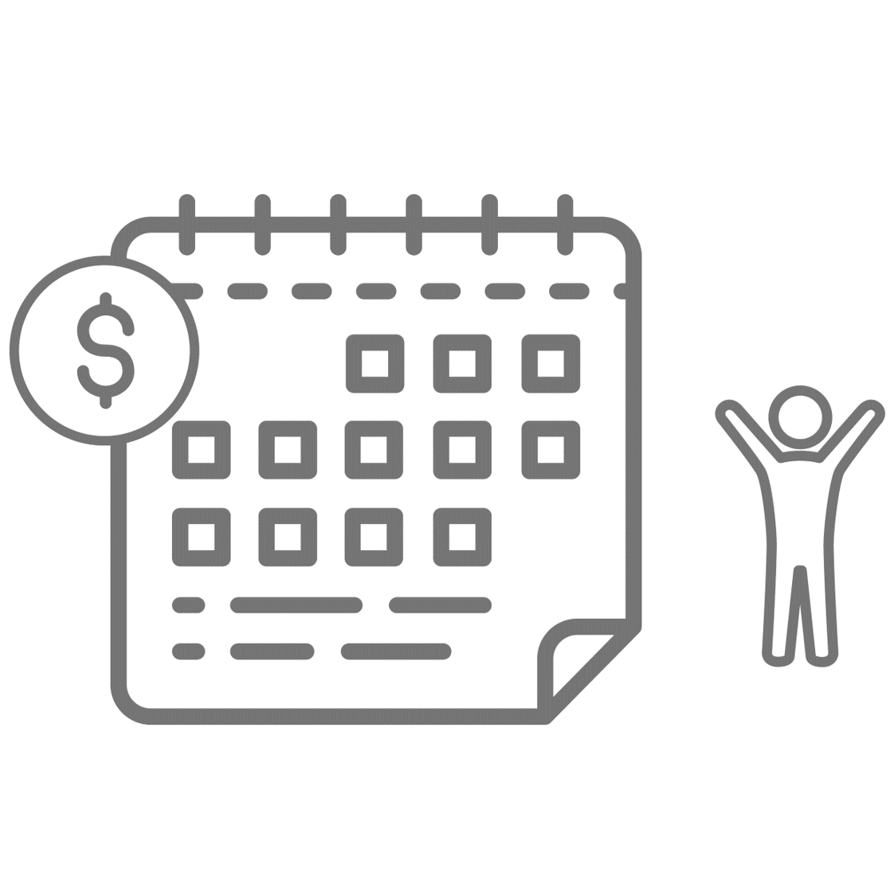2-4:00PM - CFC 101 for Nonprofits

**WEDNESDAY, JULY 24**

2:00PM - Workplace Giving Trends

3:00PM - Campaign Event Planning for Charities and Federal Agencies

**THURSDAY, JULY 25**

2:00PM - You Can Make a Difference

3:00PM - CFC Statistics

**MONDAY, AUGUST 19**

2:00PM - State of the CFC (OPM Report) and CFC-50 Commission Lookback

3:30PM - Campaign Worker Roles/Responsibilities

**TUESDAY, AUGUST 20**

2:00PM – Public Speaking Skills

2:30PM - Outreach Coordinator Updates

3:00PM - CFC 201 for Nonprofits: Best Practices - From Opportunity to Action

**WEDNESDAY, AUGUST 21**

2:00PM – Central Campaign Administrator (CCA) Applications

3:00PM - Breakouts:

1. CFC Innovations and Best Practices
2. CFC 301 for Nonprofits

**THURSDAY, AUGUST 22**

2:00PM - Promoting Volunteerism

2:30PM - CFC Ethics

3:00PM - 2024 CFC Marketing Plan

**FRIDAY, AUGUST 23 – Specific for Federal Employees Only**

2:00PM - DISC Training