Social Media – Finish Strong

Friday, Jan 10– FINISH STRONG  As we get ready to count down the final three giving days of the campaign, here’s a reminder of three great reasons to give through the @USOPM CFC:  - Give through payroll deduction – it’s easy and really adds up.  - Give to multiple charities – so many great vetted charities to choose from.  - Give for greater impact – we give so much happiness when we give together.  Please join us and GIVE HAPPY today at GiveCFC.org. #GiveCFC | Thumbnail image provided for reference. Download the actual graphic/video from the Campaign worker Toolkit before posting.  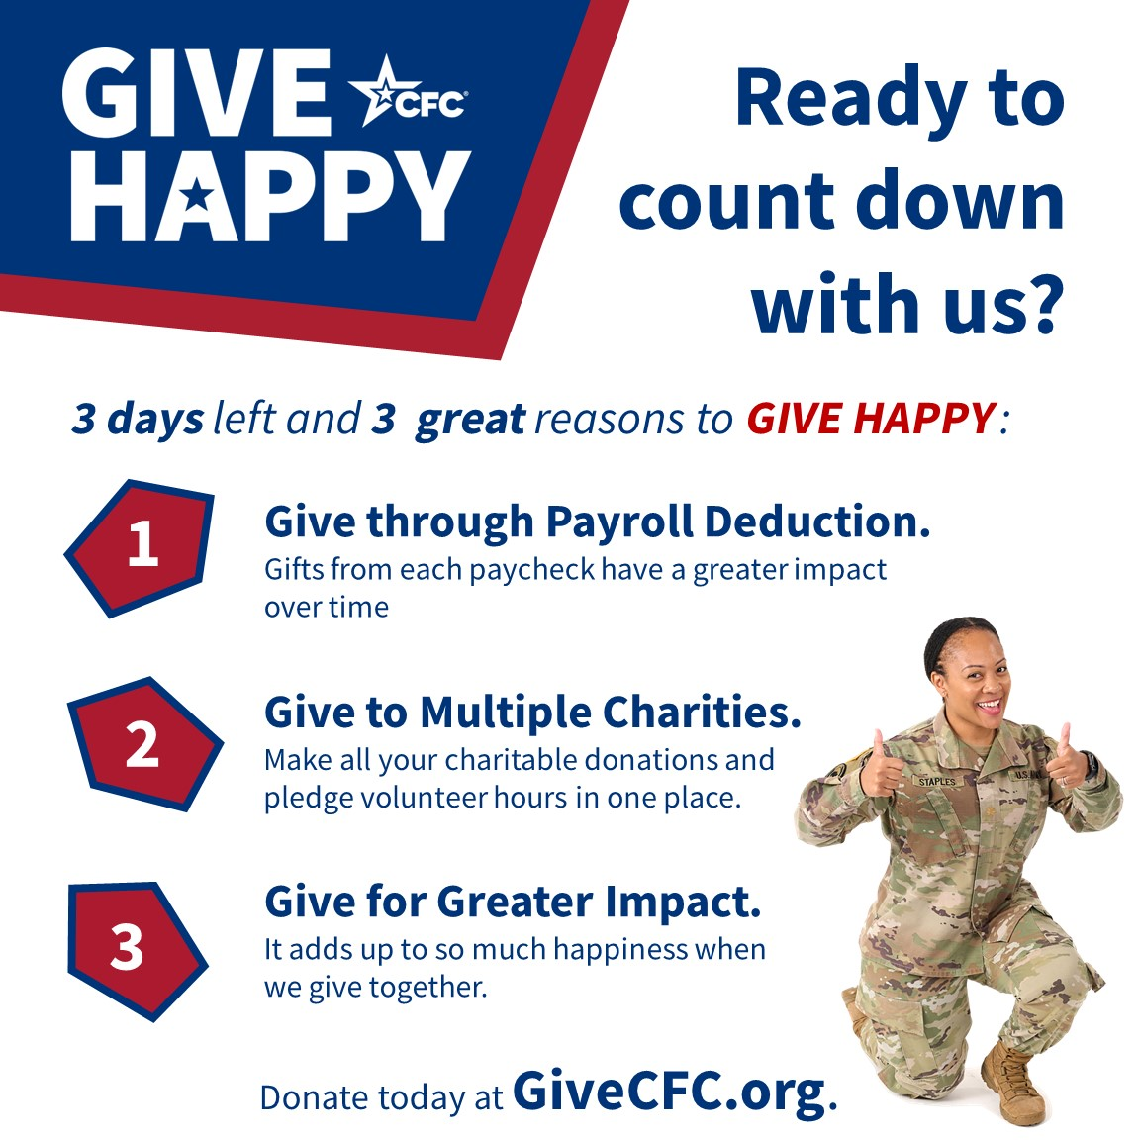 | ALT Text:  Ready to countdown with us flyer -with uniformed woman with thumbs up.
Monday, Jan 13– FINISH STRONG  There are only THREE days left to give through the @USOPM CFC!  Giving through the CFC is as easy as 1 – 2 – 3!  - Choose your cause.  - Make your pledge.  - GIVE HAPPY.  Give today at GiveCFC.org. #GiveCFC | Thumbnail image provided for reference. Download the actual graphic/video from the Campaign worker Toolkit before posting.   | ALT Text:  Red color block with #3 and three Federal employees.
Tuesday, Jan 14 – FINISH STRONG  There are only TWO days left to give through the @USOPM CFC!  Don’t forget that as Federal employees, we can make TWO types of contributions through the CFC. We can give a monetary donation AND pledge our volunteer time. If you really want to be generous, do both!  Give today at GiveCFC.org. #GiveCFC | Thumbnail image provided for reference. Download the actual graphic/video from the Campaign worker Toolkit before posting.   | ALT Text:  Red color block with #2 and two Federal employees.
Wednesday, Jan 15– FINISH STRONG  The CFC’s online giving system closes tonight! This is your ONE final opportunity to give through the CFC.  Will you go online and make a ONEtime contribution today? How can you say no to this ONE awesome way to make a difference?  Give today at GiveCFC.org. #GiveCFC | Thumbnail image provided for reference. Download the actual graphic/video from the Campaign worker Toolkit before posting.  | ALT Text:  Red color block with #1 and one Federal employee kicking up foot.

