Social Media – Giving Tuesday

Friday, Nov 29 - GIVING TUESDAY  December 3rd is Giving Tuesday - a crucial day for our CFC charities. If you haven't pledged yet, please do so. If you're new to the CFC, consider giving it a try. And if you have already pledged, thank you for your support!  Let's make #GivingTuesday the most successful day of the @USOPM CFC. Donate now at GiveCFC.org. #GiveCFC #GivingTuesday | Thumbnail image provided for reference. Download the actual graphic/video from the Campaign worker Toolkit before posting.  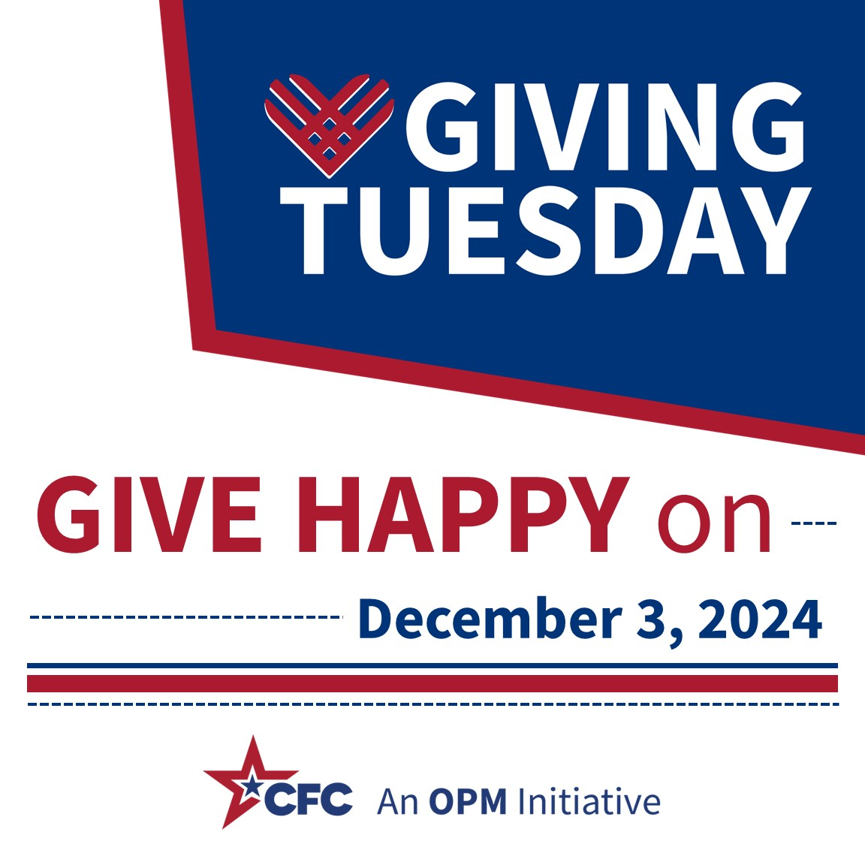 | ALT Text:  Giving Tuesday logo in blue color block with CFC logo.
Monday, Dec 2 -– GIVING TUESDAY  Tomorrow, December 3rd is Giving Tuesday. Celebrate & promote this International Day of Philanthropy and make #GivingTuesday the most successful day of the @USOPM CFC. Donate now at GiveCFC.org. #GiveCFC #GivingTuesday | Thumbnail image provided for reference. Download the actual graphic/video from the Campaign worker Toolkit before posting.  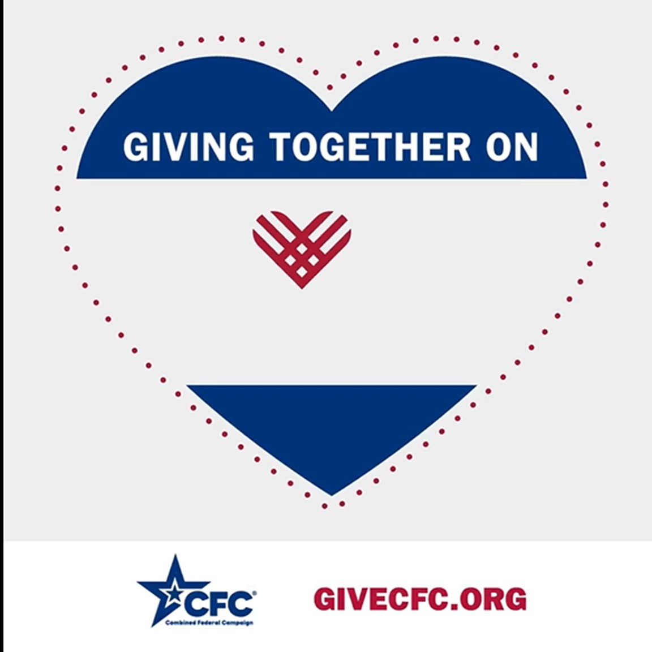 | ALT Text:  Giving Tuesday video.
Tuesday, Dec 3 – GIVING TUESDAY  Today is Giving Tuesday - a crucial day for our CFC charities. The goal is to make this the largest day of impact in the campaign. If you haven't pledged yet, please do so today. If you're new to the CFC, consider giving it a try. And if you have already pledged, thank you for your support!  Donate today at GiveCFC.org. #GiveCFC #GivingTuesday | Thumbnail image provided for reference. Download the actual graphic/video from the Campaign worker Toolkit before posting.  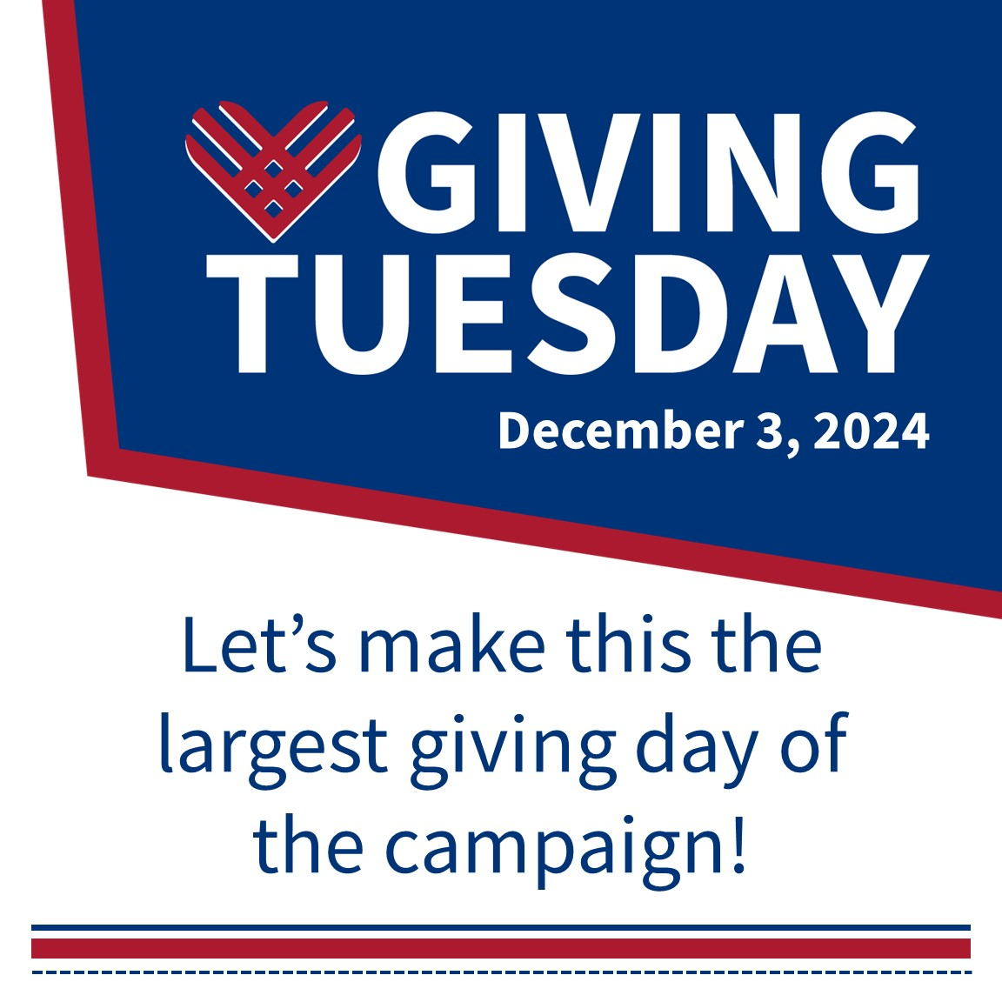 | ALT Text:  Giving Tuesday logo in blue color block.
Wednesday, Dec 4 - GIVING TUESDAY  Thanks to your support and generosity we made #GivingTuesday the biggest online pledge day of the campaign!  Don’t worry, if you were not able to donate yesterday you can still be a part of this collective impact of making the @USOPM CFC a success for the 2024 campaign! Donate today at GiveCFC.org. #GiveCFC #GivingTuesday | Thumbnail image provided for reference. Download the actual graphic/video from the Campaign worker Toolkit before posting.  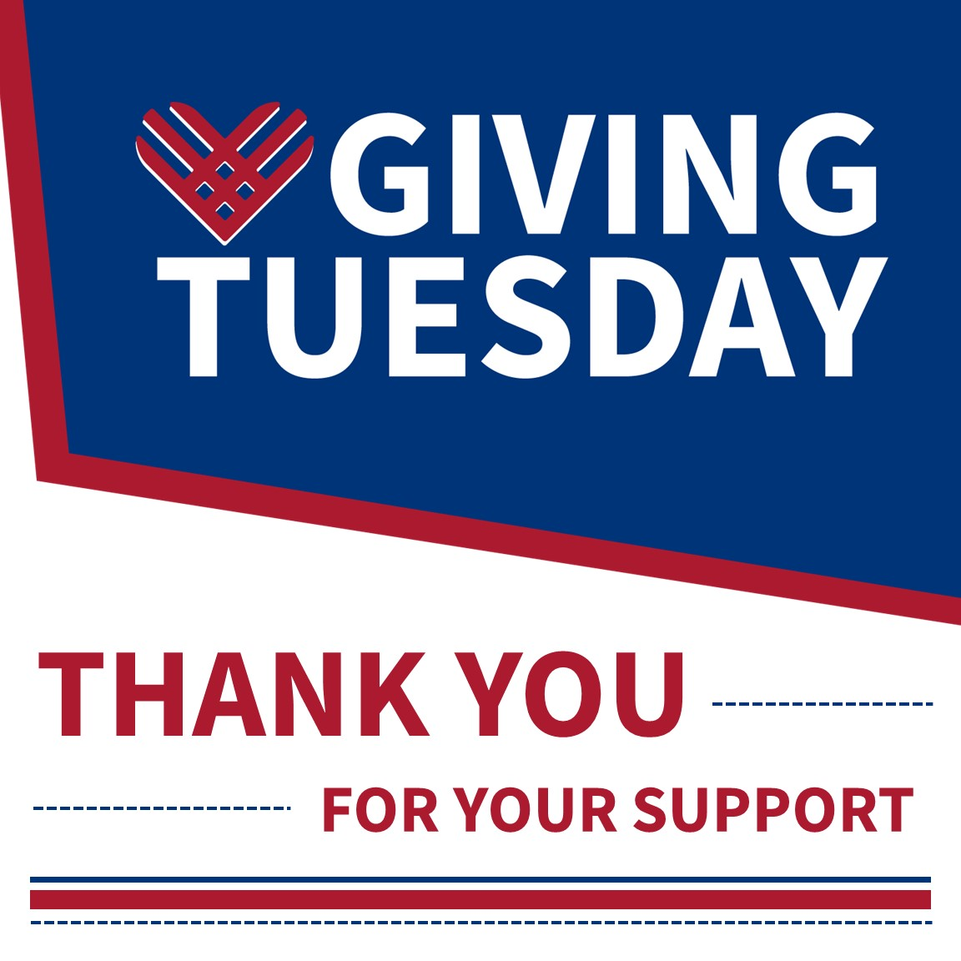 | ALT Text:  Giving Tuesday logo in blue color block.

