Purpose: The purpose of this document is to describe the process for making a CFC donation where the funds from your donation come directly to the CFC from a Third-Party Financial Institution (such as individual retirement accounts, pension plans, donor-advised funds, or other similar accounts).

Process: Donors can make pledges both through the CFC online pledging system or a paper pledge form. Separately, the funds for the accompanying donation must be sent to the CFC Processing Center to be linked to their pledge.

- Online pledge:
  - To complete an online pledge, a donor logs in to the CFC Pledge System and selects the charities they wish to support.
  - Once the donor wishes to complete the pledge and check out, they will see a payment method available called ACH-Paper Check

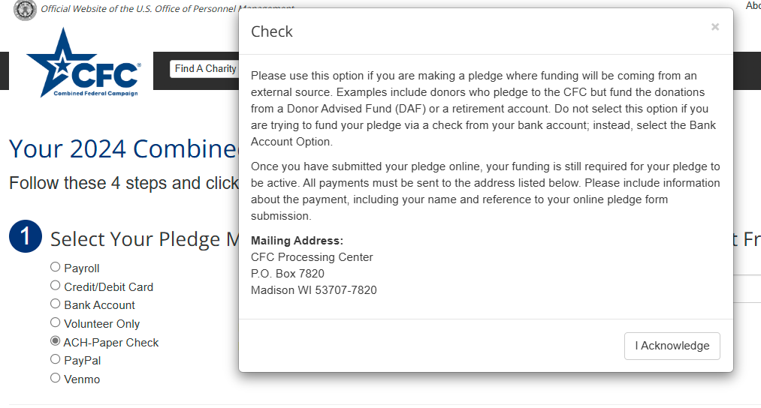
  - c. Upon selecting this option, an information module will appear, providing additional details about the payment source and an address where funds can be sent.
  - After making this selection, the donor will continue to finish their pledge checkout like any other pledge.

- Paper pledge:
  - To complete a paper pledge, a donor must complete a form via the standard paper pledging process. Paper pledge forms can be found at this link: https://givecfc.org/pledgeform
    - NOTE: The current paper pledge form does not include a separate option to note that the pledge funding source will be from a third-party financial institution. As such, select Check as the allotment source.
  - In addition to the paper pledge form, donors must submit an additional note with the pledge form indicating that funding will be sent by their Third-Party institution and provide the name of that institution.

- Funding the Pledge:
  - Once a pledge form is submitted online or via paper, donors must work with their Third-Party financial institution to send the funding matching their gift.
  - The CFC Processing Center can handle multiple fund transfer methods, including PayPal grants, bequests, ACH, bank wires, stock transfers, and paper checks. Paper checks have historically been the most common option.
    - Paper Check: Paper checks should be mailed to the address below. They should include as much information about the donor’s pledge as possible, either in the check memo field or in a cover letter accompanying the funds.
      - The funds need to include a reference to the donor’s name and the CFC. If possible, we also encourage information about the charity/CFC code from the donor’s pledge form and a reference that the funding is being sent separately from the pledge form.
      - Checks should be made payable to Give Back Foundation or The Combined Federal Campaign
      - Address: CFC Processing Center
P.O. Box 7820
Madison, WI 53707-7820

    - Electronic Funds Transfer: Multiple electronic funding methods are currently supported. Since financial institutions process electronic fund transfers differently, we prefer to handle each transfer on a case-by-case basis and will work with the donor independently to support the payment transfer.
      - For assistance making an electronic payment, please have the donor email: chris.fischer@tasconline.com and mary.rowens@tasconline.com

